# DJ Controllers: The Ultimate Buyer’s Guide 2011

###### by Phil Morse

[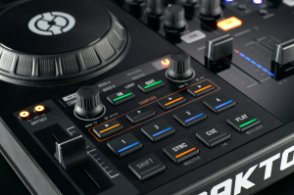](https://web.archive.org/web/20110615082944/http:/www.digitaldjtips.com/wp-content/uploads/2010/11/dj-midi-controllers-buyers-guide-2011.png)

The Traktor Kontrol S4 is one of the most desirable DJ Midi controllers on the market today.

#### ~~34~~ 36 of the best DJ Midi controllers reviewed and rated

Most people get started in digital DJing out of curiosity. They tend to download a trial or limited version of one of the big software packages such as Traktor or Virtual DJ, loading some MP3s onto the screen, and having a go. Indeed, some never progress past this stage, happy to DJ with a keyboard and mouse or trackpad.

But after a while, many start to hanker after a proper DJ controller for scratching, or at least in order to manipulate their MP3s in a more natural manner. It is now possible to duplicate every part of the traditional DJing experience (except jumping needles!), and add much more, with the best DJ controllers – but it can be difficult to know which to choose when there are so many on the market. That’s where this guide to leading DJ controllers, for beginners and experts, will help you.

### About this DJ controller guide

We’ve rounded up every major DJ controller currently on the market (or announced and imminent as of November 2010; here’s a [round-up of 4-deck controllers](https://web.archive.org/web/20110615082944/http:/www.digitaldjtips.com/2011/02/4-channel-deck-dj-midi-controllers-review-guide-2011/) from March 2011). They’re listed here in alphabetical order, by manufacturer and then model, and they range in price from pocket money to thousands. As well as rating them, we’ve shown you where to get them from in the USA, UK and Europe.

Here are some pointers to help you choose wisely:

* **Most controllers will work with most DJ software, as they allow you to “map” their controls manually.** However, all come with a version of one of the big packages, and we tell you which in the reviews. “LE” means “light edition”; if the software for a controller is not marked “LE”, assume it comes with a full commercial version of that package. Find out more here: [Bundled DJ Controller Software: Facts & Myths](https://web.archive.org/web/20110615082944/http:/www.digitaldjtips.com/2010/08/dj-controller-software-bundled/).
* **Jog wheels – the bit that replaces the record decks – have moved on immensely in recent years, and the best controllers nowadays can emulate vinyl scratching.** Don’t expect cheaper or older controllers to do this though. Here, the wheels are still useful, but they don’t sound realistic when scratched. Some controllers don’t even have jogwheels, and some people don’t miss them; most do though.
* **You may need a “sound card” too** – this will allow you to plug your headphones in for previewing, and to simultaneously have music going to the main speakers. Many controllers have a sound card built in. They need this to handle external decks, microphones and recording outputs etc. Those that don’t, we tell you. With such controllers, you simply buy a sound card separetely. Find out more here: [All About Sound Cards for Digital DJing](https://web.archive.org/web/20110615082944/http:/www.digitaldjtips.com/2010/08/sound-cards-digital-djs/).
* **We have only covered DJ Midi controllers for mainstream DJ software.** If you want to use Ableton Live, or DJ with your iPod, or use CDs too, or adapt real record decks to control your MP3s, or have a hard disk on board so you don’t need a laptop, or use a standard Midi controller to DJ with, this guide doesn’t cover your needs.
* **Our ratings are reached after careful consideration but are only a guide** – we consider usability, build quality, size/weight (we don’t want big for the hell of it, Digital DJ Tips is about portable gear you can party anywhere with), features and – of course value. We like to keep things simple, so built-in sound cards and tight software integration are seen as good things. “5″ doesn’t mean perfect, although a 5/5 piece of equipment will be highly thought of in DJ circles. Likewise, 2 doesn’t mean awful – it just means the hardware doesn’t meet enough of our criteria. Avoid anything we star with a “1″, though.
* **We know you want to look closely at the controllers!** Click on any picture for a full screen version, then click the icon in the top-right for even closer zooming.

Finally, please check all specifications, dimensions, compatibilities and so on for yourself before buying. We try our hardest, but we’re only human and just because we say something’s suitable for you, doesn’t mean it is. Do your homework – it’s part of the fun! And happy controller hunting…

• Also check out our newer [4-Deck DJ Controllers: The Ultimate Buyer’s Guide 2011](https://web.archive.org/web/20110615082944/http:/www.digitaldjtips.com/2011/02/4-channel-deck-dj-midi-controllers-review-guide-2011/)

### The controllers…

[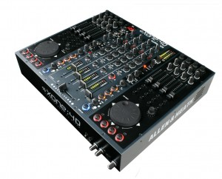](https://web.archive.org/web/20110615082944/http:/www.digitaldjtips.com/wp-content/uploads/2010/11/allen-heath-xone-d1.jpg)

Nobody will accuse you of playing with toys if you turn up at a gig with one of these.

#### Allen & Heath Xone:4D

Price: US$2,799 / [£1,699](https://web.archive.org/web/20110615082944/http:/www.amazon.co.uk/gp/product/B003SOTGDW?ie=UTF8&tag=didjti-21&linkCode=as2&camp=1634&creative=6738&creativeASIN=B003SOTGDW)https://web.archive.org/web/20110615082944im_/http:/www.assoc-amazon.co.uk/e/ir?t=didjti-21&l=as2&o=2&a=B003SOTGDW / [€1,625](https://web.archive.org/web/20110615082944/http:/www.thomann.de/index.html?partner_id=39004&page=gb/allenheath_xone4d.htm)  
Rating: ★★★★★

Supplied DJ software: Traktor LE, Ableton Live demo; Sound card: yes; Phono/line inputs: 4; Digital decks: 4; Booth/record out: yes; Mic in: yes; Power: external; Size & weight: 17 x 14 x 3.5″ (431 x 356 x 89mm), 11lb (5kg)

They say: The Xone:4D continues the seamless integration of computer-based digital media into the traditional DJ workspace, but with a further enhanced feature set.

We say: Highly professional unit aimed at the very high end with a 10-in/10-out soundcard and brilliant filters. Not the best for portable digital DJs because of its size and weight, though.

See it at Amazon.com, [Amazon.co.uk](https://web.archive.org/web/20110615082944/http:/www.amazon.co.uk/gp/product/B003SOTGDW?ie=UTF8&tag=didjti-21&linkCode=as2&camp=1634&creative=6738&creativeASIN=B003SOTGDW)https://web.archive.org/web/20110615082944im_/http:/www.assoc-amazon.co.uk/e/ir?t=didjti-21&l=as2&o=2&a=B003SOTGDW, [Thomann (UK & rest of Europe)](https://web.archive.org/web/20110615082944/http:/www.thomann.de/index.html?partner_id=39004&page=gb/allenheath_xone4d.htm)

[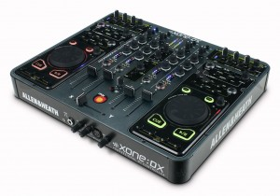](https://web.archive.org/web/20110615082944/http:/www.digitaldjtips.com/wp-content/uploads/2010/11/allen-heath-xone-dx.jpg)

Fully featured, fantastic looking, light, strong, compact and a scream to use - It's fair to say we like the Xone:DX.

#### Allen & Heath Xone:DX

Price: US$1,299 / [£907](https://web.archive.org/web/20110615082944/http:/www.amazon.co.uk/gp/product/B003GIKVIE?ie=UTF8&tag=didjti-21&linkCode=as2&camp=1634&creative=6738&creativeASIN=B003GIKVIE)https://web.archive.org/web/20110615082944im_/http:/www.assoc-amazon.co.uk/e/ir?t=didjti-21&l=as2&o=2&a=B003GIKVIE / [€1,048](https://web.archive.org/web/20110615082944/http:/www.thomann.de/index.html?partner_id=39004&page=gb/allenheath_xone_dx.htm)  
Rating: ★★★★★

Supplied DJ software: Serato ITCH. Sound card: yes; Phono/line inputs: 4; Digital decks: 4; Booth/record out: yes; Mic in: yes; Power: external; Size & weight: 15 x 14 x 2″ (381 x 356 x 51mm), 12lb (5.5kg)

They say: Professional Midi USB controllers integrated with 4-deck Serato ITCH software. The most powerful ITCH controller on the planet.

We say: Thinner, lighter and more portable than the Xone:4D and coming tightly integrated with the elegant Serato ITCH pro software and 4 decks, this is a truly complete controller.

See it at: Amazon.com, [Amazon.co.uk](https://web.archive.org/web/20110615082944/http:/www.amazon.co.uk/gp/product/B003GIKVIE?ie=UTF8&tag=didjti-21&linkCode=as2&camp=1634&creative=6738&creativeASIN=B003GIKVIE)https://web.archive.org/web/20110615082944im_/http:/www.assoc-amazon.co.uk/e/ir?t=didjti-21&l=as2&o=2&a=B003GIKVIE, [Thomann (Europe)](https://web.archive.org/web/20110615082944/http:/www.thomann.de/index.html?partner_id=39004&page=gb/allenheath_xone_dx.htm)

[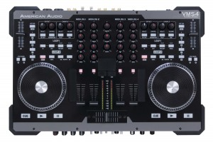](https://web.archive.org/web/20110615082944/http:/www.digitaldjtips.com/wp-content/uploads/2010/11/american-audio-vms4.jpg)

It's one of the most flexible and fully featured DJ controllers in our round up, but it's not the best built.

#### American Audio VMS4

Price: US$499 / [£327](https://web.archive.org/web/20110615082944/http:/www.thomann.de/index.html?partner_id=39004&page=gb/american_audio_vms4.htm) / [€377](https://web.archive.org/web/20110615082944/http:/www.thomann.de/index.html?partner_id=39004&page=gb/american_audio_vms4.htm)  
Rating: ★★★★★

Supplied DJ software: Virtual DJ LE; Sound card: yes; Phono/line inputs: 4; Digital decks: 4; Booth/record out: yes; Mic in: yes; Power: USB/external; Size & weight: 19.1 x 12.6 x 2.7″ (487 x 320 x 70mm), 13lb (6kg)

They say: The VMS4 is a 4-Channel “MIDILOG™” controller that fuses both Midi (Midi software) and analog audio control (CD players, turntables etc.) into one unit.

We say: You get a LOT for your money here, like 2 EQed mics, XLR outs, flexible ins, booth control, and great flexibility. Fair quality build reflected in the price.

See it at: Amazon.com, [Thomann (UK & rest of Europe)](https://web.archive.org/web/20110615082944/http:/www.thomann.de/index.html?partner_id=39004&page=gb/american_audio_vms4.htm)

[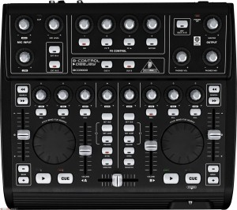](https://web.archive.org/web/20110615082944/http:/www.digitaldjtips.com/wp-content/uploads/2010/11/behringer-bcd3000.jpg)

It's lightweight and plastic, but its sober tones separate it from some of the toy-like controllers at this price point.

#### Behringer BCD3000

Price: US$144 / [£112](https://web.archive.org/web/20110615082944/http:/www.thomann.de/index.html?partner_id=39004&page=gb/behringer_bcd3000.htm) / [€129](https://web.archive.org/web/20110615082944/http:/www.thomann.de/index.html?partner_id=39004&page=gb/behringer_bcd3000.htm)  
Rating: ★★★★★

Supplied DJ software: Traktor LE; Sound card: yes; Phono/line inputs: 2 phono OR 1 line/1 phono; Digital decks: 2; Booth/record out: no; Mic in: yes; Power: USB/external; Size & weight: 13 x 11.8 x 3.9″ (330 x 300 x 99mm), 5lb (2.3kg)

They say: The B-Control Deejay BCD3000 is a next-generation DJ Machine—Play, mix, perform and scratch your MP3 files like vinyl records.

We say: Getting old now but lots of loyal users out there for this flexible DJ Midi controller. There are better options for the price nowadays, though.

See it at: Amazon.com, [Thomann (UK & rest of Europe)](https://web.archive.org/web/20110615082944/http:/www.thomann.de/index.html?partner_id=39004&page=gb/behringer_bcd3000.htm)

[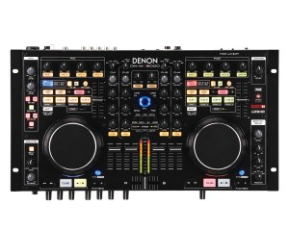](https://web.archive.org/web/20110615082944/http:/www.digitaldjtips.com/wp-content/uploads/2010/11/denon-dn-mc6000-dj-controller.jpg)

Built to the highest of standards, the DN-MC6000 also gets the functions-per-inch quota as high as it possibly can.

#### Denon DN-MC6000

Price: [US$798](https://web.archive.org/web/20110615082944/http:/www.amazon.com/gp/product/B004JJ32O4?ie=UTF8&tag=pbmo-20&linkCode=as2&camp=1789&creative=390957&creativeASIN=B004JJ32O4) / [£679](https://web.archive.org/web/20110615082944/http:/www.juno.co.uk/products/denon-dn-mc6000-dj-controller/402351-01/?ref=ddjt) / [€792](https://web.archive.org/web/20110615082944/http:/www.juno.co.uk/products/denon-dn-mc6000-dj-controller/402351-01/?ref=ddjt)  
Rating: ★★★★★

Supplied DJ software: Traktor LE (UK/Europe) / Virtual DJ 7 LE (US/Canada); Phono/line inputs: 4; Digital decks: 4; Booth/record out: yes; Mic in: yes; Power: external; Size & weight: 18.1 x 10 x 2″ (460 x 254 x 51mm), 10.3lbs (4.7kg)

They say: A 4-channel/8-source standalone digital DJ mixer with MIDI interface and internal sound card, with an astounding amount of features.

We say: Beautifully built controller that looks like the flight deck of a spaceship, it feels solid and is almost over-equipped. Works as an analogue mixer even with the laptop switched off. Quality kit.

See it at: [Amazon.com](https://web.archive.org/web/20110615082944/http:/www.amazon.com/gp/product/B004JJ32O4?ie=UTF8&tag=pbmo-20&linkCode=as2&camp=1789&creative=390957&creativeASIN=B004JJ32O4), [Juno.co.uk](https://web.archive.org/web/20110615082944/http:/www.juno.co.uk/products/denon-dn-mc6000-dj-controller/402351-01/?ref=ddjt)

[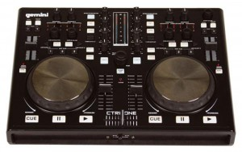](https://web.archive.org/web/20110615082944/http:/www.digitaldjtips.com/wp-content/uploads/2010/11/Gemini_ctrl_one.jpg)

The Gemini CTRL ONE is compact, portable and business-like, while not being particularly distinctive looks-wise.

#### Gemini CTRL ONE

Price: [US$199](https://web.archive.org/web/20110615082944/http:/www.bhphotovideo.com/c/search?Ntt=gemini+ctrl+one&N=0&InitialSearch=yes) / [£185](https://web.archive.org/web/20110615082944/http:/www.decks.co.uk/products/gemini/CTRL_ONE) / [€222](https://web.archive.org/web/20110615082944/http:/www.dolphinmusic.co.uk/product/44018-gemini-ctrl-one.html?locale=de_DE)  
Rating: ★★★★★

Supplied DJ software: Virtual DJ LE; Sound card: no; Digital decks: 2; Power: USB/external; Size & weight: 14 x 10.2 x 1.7″ (360 x 260 x 45mm), 3.9lbs (1.8kg)

They say: Takes your DJ techniques and concepts into the digital age! It lets you access the music stored on your computer, and manipulate it quickly and creatively.

We say: Compact and competent little controller, adjustable crossfader curve is a good (if curious) accessory on such an entry level product. You’d need a sound card too, remember.

See it at: [B&H (US)](https://web.archive.org/web/20110615082944/http:/www.bhphotovideo.com/c/search?Ntt=gemini+ctrl+one&N=0&InitialSearch=yes), [Decks.co.uk](https://web.archive.org/web/20110615082944/http:/www.decks.co.uk/products/gemini/CTRL_ONE), [Dolphin Music (Europe)](https://web.archive.org/web/20110615082944/http:/www.dolphinmusic.co.uk/product/44018-gemini-ctrl-one.html?locale=de_DE)

[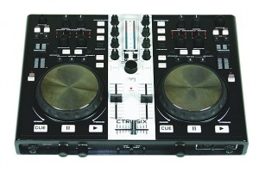](https://web.archive.org/web/20110615082944/http:/www.digitaldjtips.com/wp-content/uploads/2010/11/Gemini-CTRL-SIX.jpg)

The Geminbi CTRL SIX packs a lot of functionality into its small, nondescript casing.

#### Gemini CTRL SIX

Price: [US$249](https://web.archive.org/web/20110615082944/http:/www.bhphotovideo.com/c/search?Ntt=gemini+ctrl+six&N=0&InitialSearch=yes) / [£249](https://web.archive.org/web/20110615082944/http:/www.dolphinmusic.co.uk/product/44019-gemini-ctrl-six.html?locale=en_GB) / [€284](https://web.archive.org/web/20110615082944/http:/www.dolphinmusic.co.uk/product/44019-gemini-ctrl-six.html#euro_eu)  
Rating: ★★★★★

Supplied DJ software: Virtual DJ LE; Sound card: yes; Phono/line inputs: 2; Digital decks: 2; Booth/record out: yes; Mic in: yes; Power: USB/external; Size & weight: 14 x 10.2 x 1.7″ (360 x 260 x 45 mm), 3.9lbs (1.8kg)

They say: The new CTRL SIX provides you with not only a mixer and all the creative tools you need, but a full complement of audio input and output jacks.

We say: Basically the same as the CTRL ONE but with a decent range of ins/outs. Would make a good compact, cheap centre to an analogue/digital setup.

See it at: [B&H (US)](https://web.archive.org/web/20110615082944/http:/www.bhphotovideo.com/c/search?Ntt=gemini+ctrl+six&N=0&InitialSearch=yes), [Dolphin Music (UK)](https://web.archive.org/web/20110615082944/http:/www.dolphinmusic.co.uk/product/44019-gemini-ctrl-six.html?locale=en_GB), [Dolphin Music (Europe)](https://web.archive.org/web/20110615082944/http:/www.dolphinmusic.co.uk/product/44019-gemini-ctrl-six.html#euro_eu)

[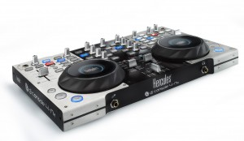](https://web.archive.org/web/20110615082944/http:/www.digitaldjtips.com/wp-content/uploads/2010/11/hercules-dj-console-4-mx.jpg)

The DJ Console 4-Mx is stylistically an improvement on the DJ Console RMX, its predecessor, while still retaining the Hercules look and feel to the knobs and buttons.

#### Hercules DJ Console 4-Mx

Price: [US$449](https://web.archive.org/web/20110615082944/http:/www.djdeals.com/herculesDJCONSOLE4MX.htm) / [£406](https://web.archive.org/web/20110615082944/http:/www.thomann.de/index.html?partner_id=39004&page=gb/hercules_dj_console_4_mx.htm) / [€468](https://web.archive.org/web/20110615082944/http:/www.thomann.de/index.html?partner_id=39004&page=gb/hercules_dj_console_4_mx.htm)  
Rating: ★★★★★

Supplied DJ software: Virtual DJ LE; Sound card: yes: Phono/line inputs: 2; Digital decks: 4; Booth/record out: no; Mic-in: yes; Power: USB; Size & weight: 15 x 9.8 x 2.6″ (381 x 249 x 63mm), 10lb (4.5kg)

They say: Large metal DJ controller with built-in audio and large jog wheels. Professional mix station for mobile and club DJs with included carry bag.

We say: The next generation of their dependable DJ Console RMX controller. Sensitive jog wheels look good, and 4 decks future-proofs it. Still somewhat clunky though.

See it at: [DJ Deals (US)](https://web.archive.org/web/20110615082944/http:/www.djdeals.com/herculesDJCONSOLE4MX.htm) / [Thomann (UK & rest of Europe)](https://web.archive.org/web/20110615082944/http:/www.thomann.de/index.html?partner_id=39004&page=gb/hercules_dj_console_4_mx.htm)

[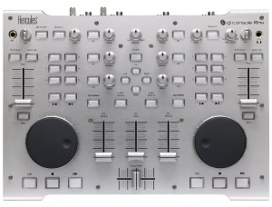](https://web.archive.org/web/20110615082944/http:/www.digitaldjtips.com/wp-content/uploads/2010/11/hercules-dj-console-rmx.jpg)

The Hercules DJ Console RMX is well made and sturdy, and has gather many fans over the years.

#### Hercules DJ Console RMX

Price: US$272 / [£233](https://web.archive.org/web/20110615082944/http:/www.thomann.de/index.html?partner_id=39004&page=gb/hercules_dj_console_rmx.htm) / [€269](https://web.archive.org/web/20110615082944/http:/www.thomann.de/index.html?partner_id=39004&page=gb/hercules_dj_console_rmx.htm)  
Rating: ★★★★★

Supplied software: Virtual DJ JE; Sound card: yes; Phono/line inputs: 2; Digital decks: 2; Booth/record out: yes; Mic in: yes; Power: USB; Size & weight: 13.8 x 10.7 x 2.6″ (350 x 250 x 68mm), 8.9lb (4kg)

They say: Cutting-edge DJ controller with built-in audio for live and studio use. Precise jog wheels and faders for mixing. Audio interface tailored for DJing.

We say: Well built, dependable controller. Jogwheels are bettered by modern controllers. Clunky to use, but won’t let you down. Good flexibility for the price.

See it at: Amazon.com, [Thomann (UK & rest of Europe)](https://web.archive.org/web/20110615082944/http:/www.thomann.de/index.html?partner_id=39004&page=gb/hercules_dj_console_rmx.htm)

[[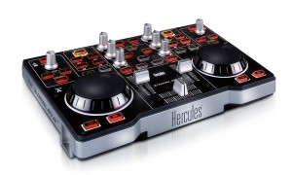](https://web.archive.org/web/20110516082122/http:/www.digitaldjtips.com/wp-content/uploads/2010/11/hercules-dj-console-mp3-e2.jpg)](https://web.archive.org/web/20110516082122/http:/www.digitaldjtips.com/wp-content/uploads/2010/11/hercules-dj-console-mp3-e2.jpg)

The tiny DJ Control MP3 e2 is a fun little controller that shouldn't be though of as a serious DJ tool for the long term.

#### Hercules DJ Control MP3 e2

Price: US$79 / [€72](https://web.archive.org/web/20110516082122/http:/www.thomann.de/index.html?partner_id=39004&page=gb/hercules_dj_control_mp3_e2.htm) / [€83](https://web.archive.org/web/20110516082122/http:/www.thomann.de/index.html?partner_id=39004&page=gb/hercules_dj_control_mp3_e2.htm)  
Rating: ★★★★★

Supplied software: Virtual DJ LE; sound card: no; Digital decks: 2; Power: USB; Size & weight: 10.5 x 9 x 2.6″ (267 x 229 x 68 mm), 1lb (0.5kg)

They say: For Beginners and casual DJs, the DJ Control MP3 e2 features 2 decks to mix 2 music tracks. Save your mixes as your own music files.

We say: Tiny unit for the casual or curious only. You’ll need a sound card too if you want to DJ as you’re meant to. If you just want to play at home every New Year’s Eve, this may be enough for you, but otherwise, get something better.

See it at: Amazon.com, [Thomann (UK & Europe)](https://web.archive.org/web/20110516082122/http:/www.thomann.de/index.html?partner_id=39004&page=gb/hercules_dj_control_mp3_e2.htm)

[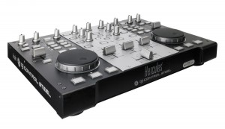](https://web.archive.org/web/20110516082122/http:/www.digitaldjtips.com/wp-content/uploads/2010/11/hercules-dj-control-steel.jpg)

Lacking the sound card of the DJ Console RMX, the DJ Control Steel has the same high-quality brushed metal casing, this time in two-tone silver and black.

#### Hercules DJ Control Steel

Price: US$190 / [£145](https://web.archive.org/web/20110516082122/http:/www.amazon.co.uk/gp/product/B002UDD1VA?ie=UTF8&tag=didjti-21&linkCode=as2&camp=1634&creative=6738&creativeASIN=B002UDD1VA)https://web.archive.org/web/20110516082122im_/http:/www.assoc-amazon.co.uk/e/ir?t=didjti-21&l=as2&o=2&a=B002UDD1VA / [€175](https://web.archive.org/web/20110516082122/http:/www.thomann.de/index.html?partner_id=39004&page=gb/hercules_dj_control_steel.htm)  
Rating: ★★★★★

Supplied software: Virtual DJ LE; Sound card: no; Digital decks: 2; Power: USB; Size & weight: 13 x 9.7 x 2.6″ (350 x 252 x 68mm), 10lb (4.5kg)

They say: Professional DJ controller for computers. Dual mixing decks on a steel surface. A wide mixing deck designed for mixing without compromise.

We say: Well built, dependable controller for DJs using their own sound card. Jogwheels bettered by modern controllers. Bit clunky, but many loyal fans.

See it at: Amazon.com, [Amazon.co.uk](https://web.archive.org/web/20110516082122/http:/www.amazon.co.uk/gp/product/B002UDD1VA?ie=UTF8&tag=didjti-21&linkCode=as2&camp=1634&creative=6738&creativeASIN=B002UDD1VA)https://web.archive.org/web/20110516082122im_/http:/www.assoc-amazon.co.uk/e/ir?t=didjti-21&l=as2&o=2&a=B002UDD1VA, [Thomann (UK & rest of Europe)](https://web.archive.org/web/20110516082122/http:/www.thomann.de/index.html?partner_id=39004&page=gb/hercules_dj_control_steel.htm)

[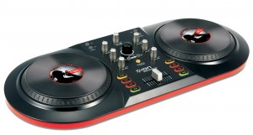](https://web.archive.org/web/20110516082122/http:/www.digitaldjtips.com/wp-content/uploads/2010/11/ion-audio-icue-3-controller.jpg)

The Ion Audio iCUE3 Discover gets it right back to basics, while managing to look funky and fun. Great for messing around with the family on, but you'll get laughed out of a DJ booth.

#### Ion Audio iCUE3 Discover

Price: US$83 / [£95](https://web.archive.org/web/20110516082122/http:/www.amazon.co.uk/gp/product/B002S53CN2?ie=UTF8&tag=didjti-21&linkCode=as2&camp=1634&creative=6738&creativeASIN=B002S53CN2)https://web.archive.org/web/20110516082122im_/http:/www.assoc-amazon.co.uk/e/ir?t=didjti-21&l=as2&o=2&a=B002S53CN2 / €108  
Rating: ★★★★★

Supplied software: MixVibes Cross LE; Sound card: No; Digital decks: 2; Power: USB; Size & weight: 12 x 7 x 4″ (304 x 178 x 101mm), 3.5lb (1.6kg)

They say: Includes everything you need to DJ with your computer. Two-deck controller with volume, EQ, pitch controls, and scratch wheel for each deck.

We say: Bold little controller looks-wise, strictly for the curious and hobbyists, and you’ll need a sound card too. For the living room it’s great but for serious DJing? No.

See it at: Amazon.com, [Amazon.co.uk](https://web.archive.org/web/20110516082122/http:/www.amazon.co.uk/gp/product/B002S53CN2?ie=UTF8&tag=didjti-21&linkCode=as2&camp=1634&creative=6738&creativeASIN=B002S53CN2)https://web.archive.org/web/20110516082122im_/http:/www.assoc-amazon.co.uk/e/ir?t=didjti-21&l=as2&o=2&a=B002S53CN2

[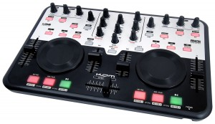](https://web.archive.org/web/20110516082122/http:/www.digitaldjtips.com/wp-content/uploads/2010/11/kam-digi-mini.jpg)

The Kam Digi Mini controller has quite a fresh look but not surprisingly considering the price, is built to a budget.

#### Kam Digi Mini

Price: US$242 / [£149](https://web.archive.org/web/20110516082122/http:/www.amazon.co.uk/gp/product/B003VRC40I?ie=UTF8&tag=didjti-21&linkCode=as2&camp=1634&creative=6738&creativeASIN=B003VRC40I)https://web.archive.org/web/20110516082122im_/http:/www.assoc-amazon.co.uk/e/ir?t=didjti-21&l=as2&o=2&a=B003VRC40I / €170  
Rating ★★★★★

Supplied software: Virtual DJ LE; Sound card: Yes; Phono/line inputs: no; Digital decks: 2; Booth/record out: no; Mic in: no; Power: USB; Size & weight: 12.2 x 8.1 x 1.5″ (310 x 205 x 38mm), 2.2lb (1kg)

They say: The Digi Mini – a sensational audio & video software controller with VirtualDJ software, headphone monitoring and FREE gig bag.

We say: Basic controller but good value for the money – it’s the cheapest controller we could find with a built-in soundcard. Don’t expect pro quality, but will do the job for a real steal of a price.

See it at: [Amazon.co.uk](https://web.archive.org/web/20110516082122/http:/www.amazon.co.uk/gp/product/B003VRC40I?ie=UTF8&tag=didjti-21&linkCode=as2&camp=1634&creative=6738&creativeASIN=B003VRC40I)https://web.archive.org/web/20110516082122im_/http:/www.assoc-amazon.co.uk/e/ir?t=didjti-21&l=as2&o=2&a=B003VRC40I

[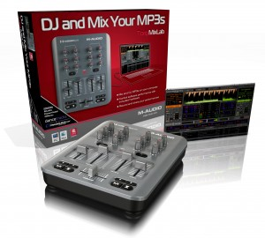](https://web.archive.org/web/20110516082122/http:/www.digitaldjtips.com/wp-content/uploads/2010/11/m-audio-torq-mixlab.jpg)

The M-Audio Torq Mixlab is probably the most minimalist complete solution in this round-up.

#### M-Audio Torq MixLab

Price: $99 / [£49](https://web.archive.org/web/20110516082122/http:/www.amazon.co.uk/gp/product/B000KU7AVM?ie=UTF8&tag=didjti-21&linkCode=as2&camp=1634&creative=6738&creativeASIN=B000KU7AVM)https://web.archive.org/web/20110516082122im_/http:/www.assoc-amazon.co.uk/e/ir?t=didjti-21&l=as2&o=2&a=B000KU7AVM / €56  
Rating: ★★★★★

Supplied software: Torq LE; Sound card: no; Digital decks: 2; Power: USB; Size & weight: 10.5 x 8.5 x 1.3″ (267 x 216 x 33mm), 2.6lb (1.2kg)

They say: The Torq MixLab™ system delivers everything you need to start producing and performing your own DJ tracks right away.

We say: No sound card means an extra buy. It’s minimal – you’ll probably miss jogs. Add in the price of a sound card and for a bit extra you could get the Kam Digi Mini which we think would be better value. Still, it’s undeniably cheap for a muck around.

See it at: Amazon.com, [Amazon.co.uk](https://web.archive.org/web/20110516082122/http:/www.amazon.co.uk/gp/product/B000KU7AVM?ie=UTF8&tag=didjti-21&linkCode=as2&camp=1634&creative=6738&creativeASIN=B000KU7AVM)https://web.archive.org/web/20110516082122im_/http:/www.assoc-amazon.co.uk/e/ir?t=didjti-21&l=as2&o=2&a=B000KU7AVM

[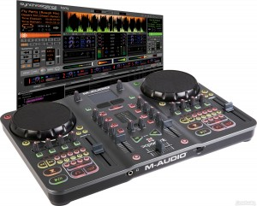](https://web.archive.org/web/20110516082122/http:/www.digitaldjtips.com/wp-content/uploads/2010/11/m-audio-torq-xponent.jpg)

Don't let the primary colours fool you - this is a serious, powerful integrated hardware/software DJ system.

#### M-Audio Torq Xponent

Price: $507 / [£359](https://web.archive.org/web/20110516082122/http:/www.amazon.co.uk/gp/product/B000RI31YC?ie=UTF8&tag=didjti-21&linkCode=as2&camp=1634&creative=6738&creativeASIN=B000RI31YC)https://web.archive.org/web/20110516082122im_/http:/www.assoc-amazon.co.uk/e/ir?t=didjti-21&l=as2&o=2&a=B000RI31YC / [€379](https://web.archive.org/web/20110516082122/http:/www.thomann.de/index.html?partner_id=39004&page=gb/maudio_torq_xponent.htm)  
Rating: ★★★★★

Supplied software: Torq 1.5; Sound card: yes; Phono/line inputs: no; Digital decks: 2; Booth/record out: yes; Mic in: no; Power: USB; Size & weight: 18 x 12 x 2.6″ (458 x 306 x 65mm), 8.2lb (3.7kg)

They say: The professional-grade Torq Xponent system seamlessly integrates high- performance DJ software with a fully functional hands-on controller.

We say: Quality full control system. High-end features include on-the-fly tempo-synced sampling, lots of FX – in some ways it’s forerunner to the Traktor Kontrol S4. No extra inputs or outputs though.

See it at: Amazon.com, [Amazon.co.uk](https://web.archive.org/web/20110516082122/http:/www.amazon.co.uk/gp/product/B000RI31YC?ie=UTF8&tag=didjti-21&linkCode=as2&camp=1634&creative=6738&creativeASIN=B000RI31YC)https://web.archive.org/web/20110516082122im_/http:/www.assoc-amazon.co.uk/e/ir?t=didjti-21&l=as2&o=2&a=B000RI31YC, [Thomann (Europe)](https://web.archive.org/web/20110516082122/http:/www.thomann.de/index.html?partner_id=39004&page=gb/maudio_torq_xponent.htm)

[https://web.archive.org/web/20110516082122im_/http:/goo.gl/cAvgv](https://web.archive.org/web/20110516082122/http:/goo.gl/PfGk9)

[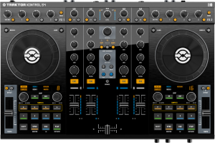](https://web.archive.org/web/20110516082122/http:/www.digitaldjtips.com/wp-content/uploads/2010/11/traktor-kontrol-s4.png)

Traktor is the most popular DJ software, so a controller designed by its makers specially for it is bound to be big news.

#### Native Instruments Traktor Kontrol S4

Price: US$899 / [£754](https://web.archive.org/web/20110516082122/http:/www.thomann.de/index.html?partner_id=39004&page=gb/native_instruments_traktor_kontrol_s4.htm) / [€869](https://web.archive.org/web/20110516082122/http:/www.thomann.de/index.html?partner_id=39004&page=gb/native_instruments_traktor_kontrol_s4.htm)  
Rating: ★★★★★

Supplied software: Traktor S4; Sound card: yes; Phono/line inputs: yes; Digital decks: 4; Booth/record out: no; Mic in: yes; Power: USB/external; Size & weight: 19.7 x 12.7 x 2″ (500 x 322 x 52mm), 7.5lb (3.4kg)

They say: Traktor Kontrol S4 was designed from its conception as a fully integrated system where software and hardware are fused in perfect harmony.

We say: A high-quality, fully integrated Traktor controller with dedicated new software boasting numerous innovations like sample decks and real-time sampling/scratching. Setting the Traktor standard. Bulky, though.

See it at: Amazon.com, [Amazon.co.uk](https://web.archive.org/web/20110516082122/http:/www.thomann.de/index.html?partner_id=39004&page=gb/native_instruments_traktor_kontrol_s4.htm), [Thomann (UK & rest of Europe)](https://web.archive.org/web/20110516082122/http:/www.thomann.de/index.html?partner_id=39004&page=gb/native_instruments_traktor_kontrol_s4.htm)

[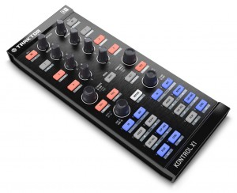](https://web.archive.org/web/20110516082122/http:/www.digitaldjtips.com/wp-content/uploads/2010/11/traktor-kontrol-x1.jpg)

It's certainly compact, and would make a good controller if all you want to do is break some of Traktor's functions out of your laptop.

#### Native Instruments Traktor Kontrol X1

Price: US$199 / [£155](https://web.archive.org/web/20110516082122/http:/www.amazon.co.uk/gp/product/B00365N9AE?ie=UTF8&tag=didjti-21&linkCode=as2&camp=1634&creative=6738&creativeASIN=B00365N9AE)https://web.archive.org/web/20110516082122im_/http:/www.assoc-amazon.co.uk/e/ir?t=didjti-21&l=as2&o=2&a=B00365N9AE / [€179](https://web.archive.org/web/20110516082122/http:/www.thomann.de/index.html?partner_id=39004&page=gb/native_instruments_traktor_kontrol_x1.htm)  
Rating: ★★★★★

Supplied software: Traktor LE; Sound card; no; Digital decks: 2; Power: USB; Size & weight: 4.7 x 11.5 x 2″ (120 x 294 x 52mm), 1.5lb (0.9kg)

They say: Provides super-intuitive control over Traktor’s looping, syncing and effects, with precision-designed knobs and plug & play functionality.

We say: You’ll need sound card to complete your set-up, and maybe a mixer – but you could use your keyboard for that. It controls Traktor’s other functions perfectly. Good if modular is your thing – you’ll probably already know if this controller is for you.

See it at: Amazon.com, [Amazon.co.uk](https://web.archive.org/web/20110516082122/http:/www.amazon.co.uk/gp/product/B00365N9AE?ie=UTF8&tag=didjti-21&linkCode=as2&camp=1634&creative=6738&creativeASIN=B00365N9AE)https://web.archive.org/web/20110516082122im_/http:/www.assoc-amazon.co.uk/e/ir?t=didjti-21&l=as2&o=2&a=B00365N9AE, [Thomann (UK & rest of Europe)](https://web.archive.org/web/20110516082122/http:/www.thomann.de/index.html?partner_id=39004&page=gb/native_instruments_traktor_kontrol_x1.htm)

[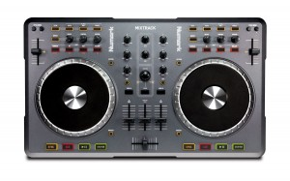](https://web.archive.org/web/20110516082122/http:/www.digitaldjtips.com/wp-content/uploads/2010/11/numark_mixtrack.jpg)

The Mixtrack is a decent size and everything is laid out clearly making it easy to use.

#### Numark Mixtrack

Price: $149 / [£128](https://web.archive.org/web/20110516082122/http:/www.amazon.co.uk/gp/product/B003UVASTO?ie=UTF8&tag=didjti-21&linkCode=as2&camp=1634&creative=6738&creativeASIN=B003UVASTO)https://web.archive.org/web/20110516082122im_/http:/www.assoc-amazon.co.uk/e/ir?t=didjti-21&l=as2&o=2&a=B003UVASTO / [€155](https://web.archive.org/web/20110516082122/http:/www.thomann.de/index.html?partner_id=39004&page=gb/numark_mixtrack.htm)  
Rating: ★★★★★

Supplied software: Traktor LE; Sound card: no;Digital decks: 2; Power: USB; Size & weight: 18.8 x 11.1 x 1.6in (478 x 282 x 40mm), 3.2lb (1.45kg)

They say: Mixtrack is a powerhouse controller in a compact chassis for performing and producing with DJ software. The layout works just like 2 decks and a mixer.

We say: Runaway successful budget controller. You’ll need a sound card and it’s made to budget, but it’s got great jogs, is well-sized and deserves its popularity. Hard to fault for the price.

See it at: Amazon.com, [Amazon.co.uk](https://web.archive.org/web/20110516082122/http:/www.amazon.co.uk/gp/product/B003UVASTO?ie=UTF8&tag=didjti-21&linkCode=as2&camp=1634&creative=6738&creativeASIN=B003UVASTO)https://web.archive.org/web/20110516082122im_/http:/www.assoc-amazon.co.uk/e/ir?t=didjti-21&l=as2&o=2&a=B003UVASTO, [Thomann (UK & rest of Europe)](https://web.archive.org/web/20110516082122/http:/www.thomann.de/index.html?partner_id=39004&page=gb/numark_mixtrack.htm)

[« Previous page of DJ Midi Controllers: The Ultimate Buyer’s Guide 2011](https://web.archive.org/web/20110722161426/http:/www.digitaldjtips.com/2010/11/dj-midi-controllers-buyers-guide-2011/2/)

[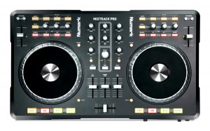](https://web.archive.org/web/20110722161426/http:/www.digitaldjtips.com/wp-content/uploads/2010/11/numark_mixtrack_pro.jpg)

The Mixtrack Pro is in the same case and has almost identical styling ot the Mixtrack, its smaller brother.

#### Numark Mixtrack Pro

Price: [$249](http://www.amazon.com/gp/product/B00466HLWO?ie=UTF8&tag=pbmo-20&link_code=wql&camp=212361&creative=380601) / [£168](https://web.archive.org/web/20110722161426/http:/www.thomann.de/index.html?partner_id=39004&page=gb/numark_mixtrack_pro.htm) / [€194](https://web.archive.org/web/20110722161426/http:/www.thomann.de/index.html?partner_id=39004&page=gb/numark_mixtrack_pro.htm)  
Rating: ★★★★★

Supplied software: Virtual DJ LE; Sound card: yes; Phono/line input: no; Digital decks: 2; Booth/record out: no; Mic in: yes; Power: USB; Size & dimensions: 18.8 x 11.1 x 1.6in (478 x 282 x 40mm), 5.1lb (2.3kg)

They say: Mixtrack Pro is a complete DJ system that works with the music on your Mac or PC. It connects to your computer so you can scratch, mix, loop, and much more.

We say: Swaps Traktor LE for Virtual DJ LE (a better choice at this level) and crucially adds a soundcard, but apart from that practically identical to the Mixtrack. Built to a price, but what a price! At this level, this controller is unbeaten.

See it at: [Amazon.com](http://www.amazon.com/gp/product/B00466HLWO?ie=UTF8&tag=pbmo-20&link_code=wql&camp=212361&creative=380601), [Thomann (UK & rest of Europe)](https://web.archive.org/web/20110722161426/http:/www.thomann.de/index.html?partner_id=39004&page=gb/numark_mixtrack_pro.htm)

Full review: See [Numark Mixtrack Pro: The Best Controller Under $250?](https://web.archive.org/web/20110722161426/http:/www.digitaldjtips.com/2010/10/numark-mixtrack-pro-review/) and [Numark Mixtrack Pro Video Review](https://web.archive.org/web/20110722161426/http:/www.digitaldjtips.com/2011/02/numark-mixtrack-pro-video-review/)

[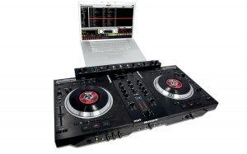](https://web.archive.org/web/20110722161426/http:/www.digitaldjtips.com/wp-content/uploads/2010/11/numark_ns7fx.jpg)

Those turntables have real record deck motors powering them, and that's real vinyl on the top... the NS7FX is no toy.

#### Numark NS7FX

Price: [$1,258](http://www.amazon.com/gp/product/B0038W9LJI?ie=UTF8&tag=pbmo-20&link_code=wql&camp=212361&creative=380601) / [£1,440](https://web.archive.org/web/20110722161426/http:/www.thomann.de/index.html?partner_id=39004&page=gb/numark_ns7fx_2.htm) / [€1,659](https://web.archive.org/web/20110722161426/http:/www.thomann.de/index.html?partner_id=39004&page=gb/numark_ns7fx_2.htm)  
Rating: ★★★★★

Supplied software: Serato ITCH; Sound card: yes; Phono/line inputs: no; Digital decks: 2; Booth/record out: yes; Mic in: yes; Power: external; Size & weight: 30 x 16 x 4″ (762 x 403 x 98 mm), 35.5 lb (16.1 kg)

They say: Designed with Serato, NS7FX represents the pinnacle of digital DJ performance. combining a premium mixer with two motorized, adjustable-torque turntables.

We say: Heavy, bulky and expensive, the NS7FX is nonetheless the best fun you can have on two virtual decks. Put your hand on your heart and say you don’t want one. Would like to see it work with the 4-deck ITCH though.

See it at: [Amazon.com](http://www.amazon.com/gp/product/B0038W9LJI?ie=UTF8&tag=pbmo-20&link_code=wql&camp=212361&creative=380601), [Thomann (UK & rest of Europe)](https://web.archive.org/web/20110722161426/http:/www.thomann.de/index.html?partner_id=39004&page=gb/numark_ns7fx_2.htm)

[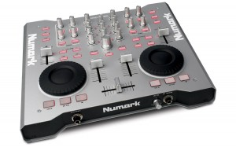](https://web.archive.org/web/20110722161426/http:/www.digitaldjtips.com/wp-content/uploads/2010/11/numark-omni-control.jpg)

Numark Omni Control is extremely well built and slight enough to slip into as bag.

#### Numark Omni Control

Price: [US$225](http://www.amazon.com/gp/product/B001L8T740?ie=UTF8&tag=pbmo-20&link_code=wql&camp=212361&creative=380601) / [£219](https://web.archive.org/web/20110722161426/http:/www.amazon.co.uk/gp/product/B001L8T740?ie=UTF8&tag=didjti-21&linkCode=as2&camp=1634&creative=6738&creativeASIN=B001L8T740)https://web.archive.org/web/20110722161426im_/http:/www.assoc-amazon.co.uk/e/ir?t=didjti-21&l=as2&o=2&a=B001L8T740 / [€268](https://web.archive.org/web/20110722161426/http:/www.thomann.de/index.html?partner_id=39004&page=gb/numark_omni_control.htm)  
Rating: ★★★★★

Supplied software: Traktor LE; Sound card: yes; Phono/line input: no; Digital decks: 2; Booth/record out: yes; Mic in: yes; Power: USB/external; Size & weight: 12.3 x 10.9 x 2.5″ (312 x 277 x 63mm), 6.8lb (3.1kg)

They say: This high-quality, heavyweight, rugged DJ device is not only a controller; it also houses a pro audio interface to feed your headphones and the sound system.

We say: Similar to the Hercules RMX controller, this is a workhorse – well made but now a little out of date. The jogs aren’t the best, but two stereo outputs is a welcome addition.

See it at: [Amazon.com](http://www.amazon.com/gp/product/B001L8T740?ie=UTF8&tag=pbmo-20&link_code=wql&camp=212361&creative=380601), [Amazon.co.uk](https://web.archive.org/web/20110722161426/http:/www.amazon.co.uk/gp/product/B001L8T740?ie=UTF8&tag=didjti-21&linkCode=as2&camp=1634&creative=6738&creativeASIN=B001L8T740)https://web.archive.org/web/20110722161426im_/http:/www.assoc-amazon.co.uk/e/ir?t=didjti-21&l=as2&o=2&a=B001L8T740, [Thomann (UK & rest of Europe)](https://web.archive.org/web/20110722161426/http:/www.thomann.de/index.html?partner_id=39004&page=gb/numark_omni_control.htm)

[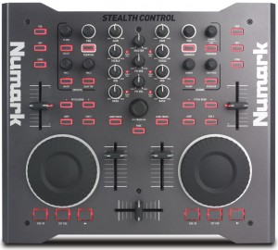](https://web.archive.org/web/20110722161426/http:/www.digitaldjtips.com/wp-content/uploads/2010/11/numark-stealth-control.jpg)

Practically identical to the Numark Omni Control, the Stealth is well built and will stand the knocks and bumps of the gigging DJ.

#### Numark Stealth Control

Price: [US$179](http://www.amazon.com/gp/product/B001PL1ON0?ie=UTF8&tag=pbmo-20&link_code=wql&camp=212361&creative=380601) / [£169](https://web.archive.org/web/20110722161426/http:/www.thomann.de/index.html?partner_id=39004&page=gb/numark_stealth_control.htm) / [€195](https://web.archive.org/web/20110722161426/http:/www.thomann.de/index.html?partner_id=39004&page=gb/numark_stealth_control.htm)  
Rating: ★★★★★

Supplied software: Traktor LE; Digital decks: 2; Power: USB/external; Size & weight: 12.3 x 10.9 x 2.5″ (312 x 277 x 63mm), 6.8lb (3.1kg)

They say: Professional DJ performance in a sleek, heavy-duty metal chassis. Spend less time with your keyboard and trackpad, and more time focused on the music.

We say: Similar to the Hercules Steel controller, this is a workhorse – well made but now a little out of date. The jogs aren’t the best, and you’ll need a sound card.

See it at: [Amazon.com](http://www.amazon.com/gp/product/B001PL1ON0?ie=UTF8&tag=pbmo-20&link_code=wql&camp=212361&creative=380601), [Thomann (UK & rest of Europe)](https://web.archive.org/web/20110722161426/http:/www.thomann.de/index.html?partner_id=39004&page=gb/numark_stealth_control.htm)

[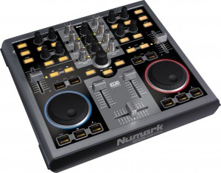](https://web.archive.org/web/20110722161426/http:/www.digitaldjtips.com/wp-content/uploads/2010/11/numark-total-control.jpg)

The Numark Total Control is built to a budget, but is well lit and looks good.

#### Numark Total Control

Price: [US$137](http://www.amazon.com/gp/product/B000QS76QC?ie=UTF8&tag=pbmo-20&link_code=wql&camp=212361&creative=380601) / [£99](https://web.archive.org/web/20110722161426/http:/www.amazon.co.uk/gp/product/B000QS76QC?ie=UTF8&tag=didjti-21&linkCode=as2&camp=1634&creative=6738&creativeASIN=B000QS76QC)https://web.archive.org/web/20110722161426im_/http:/www.assoc-amazon.co.uk/e/ir?t=didjti-21&l=as2&o=2&a=B000QS76QC / [€116](https://web.archive.org/web/20110722161426/http:/www.thomann.de/index.html?partner_id=39004&page=gb/numark_total_control.htm)  
Rating: ★★★★★

Supplied software: Traktor LE; Sound card: no; Digital decks: 2; Power: USB/external; Size & weight: 17 x 15 x 5.9″ (43.2 x 38.1 x 15.2cm), 7.5lb (3.4kg)

They say: A powerful control surface for performing and producing with DJ software. It’s portable so you can grab it and your laptop and go to wherever the gig is.

We say: Aging controller, which shows most in its now-bettered jog wheels. However, it’s reasonably well made. Hard to justify the purchase when you can pick a Mixtrack up for around the same price though.

See it at: [Amazon.com](http://www.amazon.com/gp/product/B000QS76QC?ie=UTF8&tag=pbmo-20&link_code=wql&camp=212361&creative=380601), [Amazon.co.uk](https://web.archive.org/web/20110722161426/http:/www.amazon.co.uk/gp/product/B000QS76QC?ie=UTF8&tag=didjti-21&linkCode=as2&camp=1634&creative=6738&creativeASIN=B000QS76QC)https://web.archive.org/web/20110722161426im_/http:/www.assoc-amazon.co.uk/e/ir?t=didjti-21&l=as2&o=2&a=B000QS76QC, [Thomann (UK & Europe)](https://web.archive.org/web/20110722161426/http:/www.thomann.de/index.html?partner_id=39004&page=gb/numark_total_control.htm)

[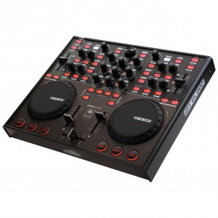](https://web.archive.org/web/20110722161426/http:/www.digitaldjtips.com/wp-content/uploads/2010/11/reloop-digital-jockey-2-controller-edition.jpg)

The Reloop Digital Jockey 2 Controller Edition is a good-looking and well laid-out DJ controller.

#### Reloop Digital Jockey 2 Controller Edition

Price: [£219](https://web.archive.org/web/20110722161426/http:/www.amazon.co.uk/gp/product/B002FJ2H00?ie=UTF8&tag=didjti-21&linkCode=as2&camp=1634&creative=6738&creativeASIN=B002FJ2H00)https://web.archive.org/web/20110722161426im_/http:/www.assoc-amazon.co.uk/e/ir?t=didjti-21&l=as2&o=2&a=B002FJ2H00 / €341  
Rating: ★★★★★

Supplied software: Traktor LE; Sound card: no; Digital decks: 4; Power: USB/external; Size & weight: 13 x 11.6 x 1.5″ (370 x 38 x 295mm), 5.5lb (2.5kg)

They say: With the Digital Jockey 2 Reloop gives Traktor DJs a controller that will make sound become truly tangible: A perfect team up.

We say: Sturdy build, a few complaints about the cue buttons failing though. Nice size, but no soundcard. Well featured and professional looking. Nice to see 4-deck support.

See it at: [Amazon.co.uk](https://web.archive.org/web/20110722161426/http:/www.amazon.co.uk/gp/product/B002FJ2H00?ie=UTF8&tag=didjti-21&linkCode=as2&camp=1634&creative=6738&creativeASIN=B002FJ2H00)https://web.archive.org/web/20110722161426im_/http:/www.assoc-amazon.co.uk/e/ir?t=didjti-21&l=as2&o=2&a=B002FJ2H00

[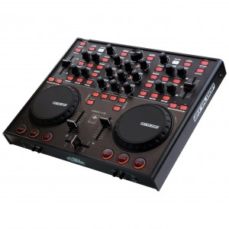](https://web.archive.org/web/20110722161426/http:/www.digitaldjtips.com/wp-content/uploads/2010/11/reloop-digital-jockey-2-interface-edition.jpg)

The interface edition is practically identical to the controller edition except of course for the sound card elements like mike and headphones inputs and RCAs round the back.

#### Reloop Digital Jockey 2 Interface Edition

Price: [US$399](http://www.amazon.com/gp/product/B00418F3NG?ie=UTF8&tag=pbmo-20&link_code=wql&camp=212361&creative=380601) / [£298](https://web.archive.org/web/20110722161426/http:/www.amazon.co.uk/gp/product/B002CTGFGK?ie=UTF8&tag=didjti-21&linkCode=as2&camp=1634&creative=6738&creativeASIN=B002CTGFGK) / €341  
Rating: ★★★★★

Supplied software: Traktor LE; Sound card: yes; Phono/line inputs: 1; Digital decks: 4; Booth/record out: no; Mic in: yes; Power: USB/external; Size and weight: 13 x 11.6 x 1.5″ (370 x 38 x 295 mm), 6lb (2.7kg)

They say: With the Digital Jockey 2, Reloop gives Traktor DJs a controller that will make sound become truly tangible: A perfect team up.

We say: Adds a soundcard, touch-sensitive jog wheels and input for one external source to the features of the interface edition. An extra line in would have been good – why just one?

See it at: [Amazon.com](http://www.amazon.com/gp/product/B00418F3NG?ie=UTF8&tag=pbmo-20&link_code=wql&camp=212361&creative=380601), [Amazon.co.uk](https://web.archive.org/web/20110722161426/http:/www.amazon.co.uk/gp/product/B002CTGFGK?ie=UTF8&tag=didjti-21&linkCode=as2&camp=1634&creative=6738&creativeASIN=B002CTGFGK)

[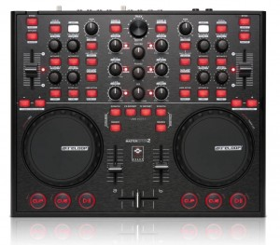](https://web.archive.org/web/20110722161426/http:/www.digitaldjtips.com/wp-content/uploads/2010/11/reloop-digital-jockey-2-master-edition.jpg)

The Reloop Digital Jockey 2 Master Edition packs a lot of technology into the same case as the rest of the Reloop controller series.

#### Reloop Digital Jockey 2 Master Edition

Price: [US$632](https://web.archive.org/web/20110722161426/http:/www.juno.co.uk/products/reloop-digital-jockey-2-master-edition/389796-01/) / [£389](https://web.archive.org/web/20110722161426/http:/www.juno.co.uk/products/reloop-digital-jockey-2-master-edition/389796-01/) / [€445](https://web.archive.org/web/20110722161426/http:/www.juno.co.uk/products/reloop-digital-jockey-2-master-edition/389796-01/)  
Rating: ★★★★★

Supplied software: Traktor LE; Sound car: yes; Phono/line inputs: 2; Digital decks: 4; Booth/record out: yes; Mic in: yes; power: external; Size & weight: 13 x 11.6 x 1.5″ (370 x 38 x 295 mm), 6lb (2.7kg)

They say: All the critically acclaimed controller features are still on board, but now it comes with symmetric output, booth output and standalone mixing.

We say: Sophisticated channel routing, club, booth and master outputs, works as an analogue mixer without laptop plugged in, and can control 4 decks. A player. Not the cheapest though.

See it at: [Juno (US)](https://web.archive.org/web/20110722161426/http:/www.juno.co.uk/products/reloop-digital-jockey-2-master-edition/389796-01/), [Juno (UK)](https://web.archive.org/web/20110722161426/http:/www.juno.co.uk/products/reloop-digital-jockey-2-master-edition/389796-01/), [Juno (rest of Europe)](https://web.archive.org/web/20110722161426/http:/www.juno.co.uk/products/reloop-digital-jockey-2-master-edition/389796-01/)

[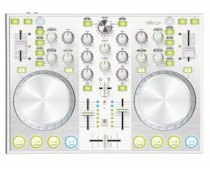](https://web.archive.org/web/20110722161426/http:/www.digitaldjtips.com/wp-content/uploads/2010/11/reloop-mixage-ce-ltd.jpg)

We quite like the bold whites, silvers and lime greens of the Mixage CE LTD.

#### Reloop Mixage CE LTD

Price: To be announced  
Rating: ★★★★★

Supplied software: Traktor LE; Sound card: No; Digital decks: 4 (requires Traktor Pro); Power: USB/external; Size & weight: 14.6 x 10.2 x 1.7″ (370 x 258 x 44mm), 4.2lb (1.9 kg)

They say: The perfect introduction to digital mixing: based on the Digital Jockey, The Reloop Mixage CE LTD does not accept compromise on quality and feeling.

We say: Adjustable backlight brightness and 4-deck support are pro features. But unless you already have a sound card (or are also taken with the curious white and lime green colour scheme!), best going for the bigger brother, the Mixage IE.

See it at: [Reloop website](https://web.archive.org/web/20110722161426/http:/www.reloopdj.com/product_info.php/info/p616_Reloop-Mixage-IE.html/)

[« Previous page of DJ Midi Controllers: The Ultimate Buyer’s Guide 2011](https://web.archive.org/web/20110721010209/http:/www.digitaldjtips.com/2010/11/dj-midi-controllers-buyers-guide-2011/3/)

[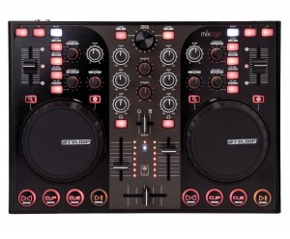](https://web.archive.org/web/20110721010209/http:/www.digitaldjtips.com/wp-content/uploads/2010/11/reloop-mixage-ie.jpg)

The compact but powerful Reloop Mixage IE - note the big cue buttons, which are assignable.

#### Reloop Mixage IE

Price: US$329 / £255 / €290  
Rating: ★★★★★

Supplied software: Traktor LE; Sound car: yes; Phono/line inputs: no; Digital decks: 4 (with Traktor Pro); Booth/record out: no; Mic in: yes; Power: USB/external; Size & weight: 14.6 x 10.2 x 1.7″ (370 x 258 x 44mm), 4.2lb (1.9 kg)

They say: The perfect introduction to digital mixing: based on the Digital Jockey, The Reloop Mixage IE does not accept compromise when regarding quality and feeling.

We say: May even take some sales off the Digital Jockey 2 series – well made little controller with four reassignable buttons that could easily be used as cues, plus 4-deck support and an adjustable backlight.

See it at: [Reloop website](https://web.archive.org/web/20110721010209/http:/www.reloopdj.com/product_info.php/info/p616_Reloop-Mixage-IE.html/XTCsid/0f9d1a97c720477a7788474ff50b4af2)

Full review and video: [Review & Video: Reloop Mixage DJ Controller](https://web.archive.org/web/20110721010209/http:/www.digitaldjtips.com/2011/05/review-video-reloop-mixage-dj-controller/)

[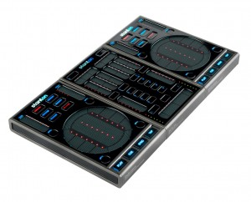](https://web.archive.org/web/20110721010209/http:/www.digitaldjtips.com/wp-content/uploads/2010/11/stanton-scs3-dj-control-system.jpg)

One of the best looking little controllers in the test, with three parts that clip together magnetically.

#### Stanton SCS3 DJ Control System

Price: [US$499](http://www.amazon.com/gp/product/B002TP500E?ie=UTF8&tag=pbmo-20&link_code=wql&camp=212361&creative=380601) / [£379](https://web.archive.org/web/20110721010209/http:/www.dolphinmusic.co.uk/product/47327-stanton-sc-system-3-controller-package.html?locale=en_GB) / [€433](https://web.archive.org/web/20110721010209/http:/www.dolphinmusic.co.uk/product/47327-stanton-sc-system-3-controller-package.html?locale=de_DE)  
Rating: ★★★★★

Supplied software: Traktor LE; Sound card: no; Digital decks: 4; Power: USB; Size & weight: 14.2 x 8.5 x 1.4in (360 x 216 x 35mm), 3.5lb (1.6kg)

They say: The most innovative, completely mobile Midi control solution available, with 2 touch-sensitive control surfaces for customizable software control.

We say: Compact, innovative, clever and capable, this is a bold and well thought-out innovation from Stanton. True portable DJing – it even splits up into three parts for stashing. You’ll need a sound card though.

See it at: [Amazon.com](http://www.amazon.com/gp/product/B002TP500E?ie=UTF8&tag=pbmo-20&link_code=wql&camp=212361&creative=380601), [Dolphin Music (UK)](https://web.archive.org/web/20110721010209/http:/www.dolphinmusic.co.uk/product/47327-stanton-sc-system-3-controller-package.html?locale=en_GB), [Dolphin Music (rest of Europe)](https://web.archive.org/web/20110721010209/http:/www.dolphinmusic.co.uk/product/47327-stanton-sc-system-3-controller-package.html?locale=de_DE)

Full review: [Stanton SC System 3 Review: The First Truly Portable DJ Controller?](https://web.archive.org/web/20110721010209/http:/www.digitaldjtips.com/2010/11/stanton-sc-system-3-review/)

[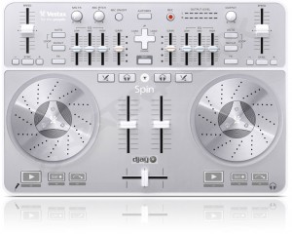](https://web.archive.org/web/20110721010209/http:/www.digitaldjtips.com/wp-content/uploads/2010/11/vestax-spin-dj-controller.jpg)

Styled to look great sat next to your Mac, the Vestax Spin is smaller than you might imagine.

#### Vestax Spin

Price: US$249 / [£205](https://web.archive.org/web/20110721010209/http:/www.amazon.co.uk/gp/product/B00317CSNQ?ie=UTF8&tag=didjti-21&linkCode=as2&camp=1634&creative=6738&creativeASIN=B00317CSNQ)https://web.archive.org/web/20110721010209im_/http:/www.assoc-amazon.co.uk/e/ir?t=didjti-21&l=as2&o=2&a=B00317CSNQ / [€229](https://web.archive.org/web/20110721010209/http:/www.thomann.de/index.html?partner_id=39004&page=gb/vestax_spin.htm)  
Rating: ★★★★★

Supplied software: djay; Sound card: yes; Phono/line inputs: no; Digital decks: 2; Booth/record out: no; Mic in: yes; Power; USB; Size & weight: 14 x 9.5 x 1.5″ (356 x 241 x 38mm), 3.3lb (1.5kg)

They say: Designed for Mac, Spin is the perfect all-in-one bundle of digital DJ hardware and software. It offers total control to mix, scratch, and play music as a DJ would.

We say: Compact home DJ set-up, even comes with a mike. Consumer-quality but a joy to use with good jogs & easy, dedicated software including great iTunes integration.

See it at: [Amazon.co.uk](https://web.archive.org/web/20110721010209/http:/www.amazon.co.uk/gp/product/B00317CSNQ?ie=UTF8&tag=didjti-21&linkCode=as2&camp=1634&creative=6738&creativeASIN=B00317CSNQ)https://web.archive.org/web/20110721010209im_/http:/www.assoc-amazon.co.uk/e/ir?t=didjti-21&l=as2&o=2&a=B00317CSNQ, [Thomann (UK & rest of Europe)](https://web.archive.org/web/20110721010209/http:/www.thomann.de/index.html?partner_id=39004&page=gb/vestax_spin.htm)

Full review: [Vestax Spin DJ Controller Review](https://web.archive.org/web/20110721010209/http:/www.digitaldjtips.com/2010/09/vestax-spin-dj-controller-review/)

[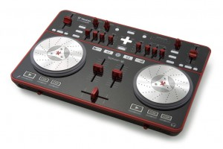](https://web.archive.org/web/20110721010209/http:/www.digitaldjtips.com/wp-content/uploads/2010/11/vestax-typhoon.jpg)

Its bold styling may not be to everyone's taste, but it's fun to use thanks to Vestax's top-quality jog wheels.

#### Vestax Typhoon

Price: [US$279](http://www.amazon.com/gp/product/B003ISMOV4?ie=UTF8&tag=pbmo-20&link_code=wql&camp=212361&creative=380601) / [£199](https://web.archive.org/web/20110721010209/http:/www.amazon.co.uk/gp/product/B003ISMOV4?ie=UTF8&tag=didjti-21&linkCode=as2&camp=1634&creative=6738&creativeASIN=B003ISMOV4)https://web.archive.org/web/20110721010209im_/http:/www.assoc-amazon.co.uk/e/ir?t=didjti-21&l=as2&o=2&a=B003ISMOV4 / [€235](https://web.archive.org/web/20110721010209/http:/www.thomann.de/index.html?partner_id=39004&page=gb/vestax_typhoon.htm)  
Rating: ★★★★★

Supplied software: Traktor LE; Sound card: yes; Phono/line: no; Digital decks: 2; Booth/record out: no; Mic in: yes; Power: USB; Size & weight: 14 x 9.5 x 1.5″ (356 x 241 x 38mm), 3.3lb (1.5kg)

They say: Typhoon is an all-in-one bundle of digital DJ hardware and software, offering total control to mix, scratch, and play music as a DJ would right at your fingertips.

We say: Compact home DJ set-up. Consumer-quality but a joy to use with good jog wheels. Sliders are a little unusual but if you can live with the styling, it’s a good basic Traktor controller.

See it at: [Amazon.com](http://www.amazon.com/gp/product/B003ISMOV4?ie=UTF8&tag=pbmo-20&link_code=wql&camp=212361&creative=380601), [Amazon.co.uk](https://web.archive.org/web/20110721010209/http:/www.amazon.co.uk/gp/product/B003ISMOV4?ie=UTF8&tag=didjti-21&linkCode=as2&camp=1634&creative=6738&creativeASIN=B003ISMOV4)https://web.archive.org/web/20110721010209im_/http:/www.assoc-amazon.co.uk/e/ir?t=didjti-21&l=as2&o=2&a=B003ISMOV4, [Thomann (UK and rest of Europe)](https://web.archive.org/web/20110721010209/http:/www.thomann.de/index.html?partner_id=39004&page=gb/vestax_typhoon.htm)

Full review: [Review: Vestax Typhoon DJ Controller](https://web.archive.org/web/20110721010209/http:/www.digitaldjtips.com/2010/08/review-vestax-typhoon-dj-controller/)

[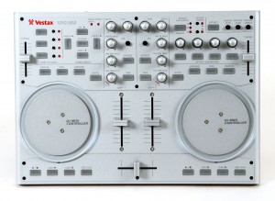](https://web.archive.org/web/20110721010209/http:/www.digitaldjtips.com/wp-content/uploads/2010/11/vestax-vci-100.jpg)

The Vestax VCI-100 was the first controller people started taking seriously, and it was immensely popular. It is still a good buy today.

#### Vestax VCI-100

Price: [US$479](http://www.amazon.com/gp/product/B000OI1M3C?ie=UTF8&tag=pbmo-20&link_code=wql&camp=212361&creative=380601) / [£280](https://web.archive.org/web/20110721010209/http:/www.amazon.co.uk/gp/product/B000OI1M3C?ie=UTF8&tag=didjti-21&linkCode=as2&camp=1634&creative=6738&creativeASIN=B000OI1M3C)https://web.archive.org/web/20110721010209im_/http:/www.assoc-amazon.co.uk/e/ir?t=didjti-21&l=as2&o=2&a=B000OI1M3C / [€377](https://web.archive.org/web/20110721010209/http:/www.thomann.de/index.html?partner_id=39004&page=gb/vestax_vci_100_dj_midi_controller.htm)  
Rating: ★★★★★

Supplied software: Traktor LE; Sound card: no; Digital decks: 2; Power: USB/external; Size & weight: 14.1 x 9.9 x 1.4in (360 × 252 × 35mm), 5.7lb (2.6kg)

They say: The VCI-100 is a highly professional MIDI controller that has two jog wheels built with sensor and control technology straight from our turntables.

We say: Arguably the first “serious” Dj controller. Built like a tank, highly popular, highly adaptable. Famously hacked by Ean Golden of [DJTechTools](https://web.archive.org/web/20110721010209/http:/www.djtechtools.com/). No sound card though.

See it at: [Amazon.com](http://www.amazon.com/gp/product/B000OI1M3C?ie=UTF8&tag=pbmo-20&link_code=wql&camp=212361&creative=380601), [Amazon.co.uk](https://web.archive.org/web/20110721010209/http:/www.amazon.co.uk/gp/product/B000OI1M3C?ie=UTF8&tag=didjti-21&linkCode=as2&camp=1634&creative=6738&creativeASIN=B000OI1M3C)https://web.archive.org/web/20110721010209im_/http:/www.assoc-amazon.co.uk/e/ir?t=didjti-21&l=as2&o=2&a=B000OI1M3C, [Thomann (UK & rest of Europe)](https://web.archive.org/web/20110721010209/http:/www.thomann.de/index.html?partner_id=39004&page=gb/vestax_vci_100_dj_midi_controller.htm)

[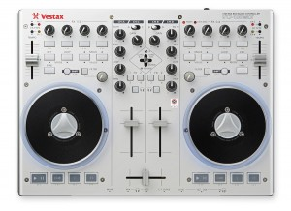](https://web.archive.org/web/20110721010209/http:/www.digitaldjtips.com/wp-content/uploads/2010/11/vci-100-mk-ii.jpg)

More logically laid out but with blue underlighting that may not be to everyone's taste: The Vestax VCI-100 MkII.

#### Vestax VCI-100 MkII

Price: [US$630](https://web.archive.org/web/20110721010209/http:/www.amazon.com/gp/product/B0046OY64C?ie=UTF8&tag=pbmo-20&linkCode=as2&camp=1789&creative=390957&creativeASIN=B0046OY64C)https://web.archive.org/web/20110721010209im_/http:/www.assoc-amazon.com/e/ir?t=pbmo-20&l=as2&o=1&a=B0046OY64C / [£399](https://web.archive.org/web/20110721010209/http:/www.juno.co.uk/products/vestax-vci-100-mkii-usb-midi-dj-controller/407589-01/?currency=GBP&ref=ddjt) / [€467](https://web.archive.org/web/20110721010209/http:/www.juno.co.uk/products/vestax-vci-100-mkii-usb-midi-dj-controller/407589-01/?currency=EUR&ref=ddjt)  
Rating: ★★★★★

Supplied software: Traktor LE; Decks usable with supplied software: ; Sound card: yes; Phono/line in: no; Physical channels: 2; Booth/record out: yes; Mic in: no; Power: USB/external; Size & weight: 14.1 x 10.6 x 1.5″ (368 x 270 x 38mm), 4.4lb (2kg)

They say: Over the years as the entire DJ scene made its shift to computer based DJing, we kept collecting requests and demands for a new model. Here it is: VCI-100 MkII.

We say: It’s lighter, still well made, it’s got 4-deck control, it has a built-in sound card, the jog wheels have torque controls, and it’s jam-packed with features. Would be better with a mic input and ideally external line/phono inputs too.

See it at: [Amazon.com](https://web.archive.org/web/20110721010209/http:/www.amazon.com/gp/product/B0046OY64C?ie=UTF8&tag=pbmo-20&linkCode=as2&camp=1789&creative=390957&creativeASIN=B0046OY64C)https://web.archive.org/web/20110721010209im_/http:/www.assoc-amazon.com/e/ir?t=pbmo-20&l=as2&o=1&a=B0046OY64C, [Juno (UK, rest of Europe, world)](https://web.archive.org/web/20110721010209/http:/www.juno.co.uk/products/vestax-vci-100-mkii-usb-midi-dj-controller/407589-01/?currency=GBP&ref=ddjt)

Full review: [Vestax VCI-100 Mk II DJ Controller Review](https://web.archive.org/web/20110721010209/http:/www.digitaldjtips.com/2010/10/vestax-vci-100-mk-ii-review/)

[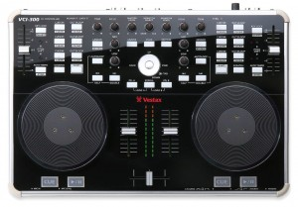](https://web.archive.org/web/20110721010209/http:/www.digitaldjtips.com/wp-content/uploads/2010/11/vestax-vci-300.jpg)

Solidly built and impressive in matt silver and black gloss, the VCI-300 has won design awards.

#### Vestax VCI-300

Price: [US$779](http://www.amazon.com/gp/product/B0019OML12?ie=UTF8&tag=pbmo-20&link_code=wql&camp=212361&creative=380601) / [£533](https://web.archive.org/web/20110721010209/http:/www.thomann.de/index.html?partner_id=39004&page=gb/vestax_vci300.htm) / [€615](https://web.archive.org/web/20110721010209/http:/www.thomann.de/index.html?partner_id=39004&page=gb/vestax_vci300.htm)  
Rating: ★★★★★

Supplied software: Serato ITCH; Sound card: yes; Phono/line inputs: no; Digital decks: 2; Booth/record outputs: no; Mic in: yes; Power: USB/external; Size & weight: 14.1 x 9.9 x 1.4″ (410 x 272 x 40mm), 7.1lb (3.2kg)

They say: Sharing their technology and feedback from Pro DJs and users, Vestax and Serato have created a dedicated DJ system offering absolute control.

We say: Elegant, brilliantly made and highly professional DJ system that’s a joy to use – but like the NS7, four-deck control would be nice.

See it at: [Amazon.com](http://www.amazon.com/gp/product/B0019OML12?ie=UTF8&tag=pbmo-20&link_code=wql&camp=212361&creative=380601), [Thomann (UK & rest of Europe)](https://web.archive.org/web/20110721010209/http:/www.thomann.de/index.html?partner_id=39004&page=gb/vestax_vci300.htm)

Full review: [Vestax VCI-300 & Serato ITCH – 3 Months In](https://web.archive.org/web/20110721010209/http:/www.digitaldjtips.com/2010/03/vestax-vci-300-serato-itch-review/)

[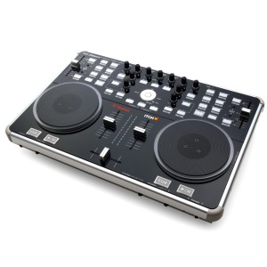](https://web.archive.org/web/20110721010209/http:/www.digitaldjtips.com/wp-content/uploads/2010/11/vci-300-mk-ii.jpg)

To look at, the VCI-300 MkII is identical to the VCI-300. the changes are all under the hood.

#### Vestax VCI-300 MkII

Price: [US$799](http://www.amazon.com/gp/product/B003V35A76?ie=UTF8&tag=pbmo-20&link_code=wql&camp=212361&creative=380601) / [£569](https://web.archive.org/web/20110721010209/http:/www.amazon.co.uk/gp/product/B003V35A76?ie=UTF8&tag=didjti-21&linkCode=as2&camp=1634&creative=6738&creativeASIN=B003V35A76)https://web.archive.org/web/20110721010209im_/http:/www.assoc-amazon.co.uk/e/ir?t=didjti-21&l=as2&o=2&a=B003V35A76 / [€799](https://web.archive.org/web/20110721010209/http:/www.thomann.de/index.html?partner_id=39004&page=gb/vestax_vci300_mkii.htm)  
Rating: ★★★★★

Supplied software: Serato ITCH; Sound card: yes; Phono/line inputs: no; Digital decks: 2; Booth/record outputs: no; Mic in: yes; Power: USB/external; Size & weight: 14.1 x 9.9 x 1.4″ (410 x 272 x 40mm), 7.1lb (3.2kg)

They say: Preserving the concept of the VCI-300 and ITCH, the VCI-300MkII comes with usability improvements based on feedback from VCI-300 customers.

We say: Just a few barely perceptable niggles from the original VCI-300 (headphone volume being the main one) have been correcting, made this controller close to perfect for the professional DJ who wants to keep things simple yet powerful.

See it at: [Amazon.com](http://www.amazon.com/gp/product/B003V35A76?ie=UTF8&tag=pbmo-20&link_code=wql&camp=212361&creative=380601), [Amazon.co.uk](https://web.archive.org/web/20110721010209/http:/www.amazon.co.uk/gp/product/B003V35A76?ie=UTF8&tag=didjti-21&linkCode=as2&camp=1634&creative=6738&creativeASIN=B003V35A76)https://web.archive.org/web/20110721010209im_/http:/www.assoc-amazon.co.uk/e/ir?t=didjti-21&l=as2&o=2&a=B003V35A76, [Thomann (UK & rest of Europe)](https://web.archive.org/web/20110721010209/http:/www.thomann.de/index.html?partner_id=39004&page=gb/vestax_vci300_mkii.htm)

[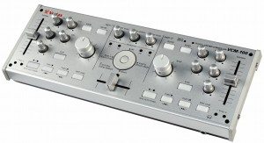](https://web.archive.org/web/20110721010209/http:/www.digitaldjtips.com/wp-content/uploads/2010/11/vestax-vcm-100.jpeg)

The VCM-100 will appeal to minimalists - especially if you're happy to use your laptop itself for cues, looping etc.

#### Vestax VCM-100

Price: [US$269](http://www.amazon.com/gp/product/B00167PMTA?ie=UTF8&tag=pbmo-20&link_code=wql&camp=212361&creative=380601) / [£296](https://web.archive.org/web/20110721010209/http:/www.juno.co.uk/products/vestax-vcm-100-usb-midi-audio-controller/363302-01/) / [€342](https://web.archive.org/web/20110721010209/http:/www.juno.co.uk/products/vestax-vcm-100-usb-midi-audio-controller/363302-01/)  
Rating: ★★★★★

Supplied software: Traktor LE; Sound card: yes; Phono/line ins: 2; Digital decks: 2; Booth/record out: yes; Mic in: no; Power: USB/external; Size & weight: 1.8kg 13.8 x 5 x 1.6″ (350 x 126 x 40mm), 4lb (1.8kg)

They say: A compact USB MIDI & audio system, Despite its size, the VCM-100 comes with stereo x 2 in/out connection, phones output and high quality controls.

We say: Highly portable and well made, if identikit controllers leave you cold, this could be what you’re looking for – especially if you don’t see the point of jogwheels.

See it at: [Amazon.com](http://www.amazon.com/gp/product/B00167PMTA?ie=UTF8&tag=pbmo-20&link_code=wql&camp=212361&creative=380601), [Juno (UK)](https://web.archive.org/web/20110721010209/http:/www.juno.co.uk/products/vestax-vcm-100-usb-midi-audio-controller/363302-01/), [Juno (rest of Europe)](https://web.archive.org/web/20110721010209/http:/www.juno.co.uk/products/vestax-vcm-100-usb-midi-audio-controller/363302-01/)

### Conclusion

There are some truly magnificent controllers here. The truth is that you could record killer DJ sets on absolutely any of them.

Our advice is to choose first and foremost whether you want a built-in sound card or a separate one, then whether you want two or four decks, then set your budget and start sifting through.

There are some truly magnificent controllers here. The truth is that you could record killer DJ sets on absolutely any of them.

In the end, go with your gut feeling. You’re going to spend a lot of time in the company of the one you choose, so go with something that looks good to you, and that you can see yourself performing on in front of a crowd of people.

Good luck!

Do you agree with our ratings? Are there any controllers we’ve left out you’d like to see included? Have you had good or bad experiences with any of these controllers? Please let us know in the comments.

**Now go to:**  
[4-Deck DJ Controllers: The Ultimate Buyer’s Guide 2011](https://web.archive.org/web/20110721010209/http:/www.digitaldjtips.com/2011/02/4-channel-deck-dj-midi-controllers-review-guide-2011/)  
[Choosing a Digital DJing Controller](https://web.archive.org/web/20110721010209/http:/www.digitaldjtips.com/2010/06/choosing-a-digital-djing-controller/)  
[5 Reasons Why Digital DJing Beats Vinyl](https://web.archive.org/web/20110721010209/http:/www.digitaldjtips.com/2010/03/five-reasons-why-digital-djing-beats-vinyl/)

**Want to join the Digital DJ Tips club?**  
Find out about all the benefits of joining our [FREE DJ-only member's club](https://web.archive.org/web/20110721010209/http:/www.digitaldjtips.com/access-all-areas/).

**Get your copy of our latest free e-book - instantly!**  
Grab "The Ten Commandments Of Digital DJing" from our [Facebook Page](https://web.archive.org/web/20110721010209/http:/www.facebook.com/digitaldjtips?sk=app_163958263671955) rig

#### 9 leading four-channel DJ Midi controllers reviewed and rated

DJs have always loved extra decks and channels. Back in the dark ages when every DJ box had Technics record decks and standard mixer, to find a DJ box with three or even four Technics in it was something special. Today, with all major DJ software now coming with four decks as a minimum, the controllers are catching up. So far 2011 has seen a rake of new four channel hardware hit the market, joining the small number of four-deck controllers that had already become available over the past year or so.

### About this guide

We’ve rounded up every single major four-channel DJ Midi controller with jogwheels currently on the market (or announced and imminent). They’re listed here in alphabetical order, by manufacturer and then model, and they range in price from pocket money to thousands. As well as rating them, we’ve shown you where to get them from in the USA, UK and Europe, and where we can, worldwide.

Where we haven’t had a chance to use a controller ourselves, we base our round-up notes on the experiences of community members who have, so you can be sure you’re getting an informed opinion.

Having said that, some of them are so new that they’ve only been demoed by the manufacturer at trade shows – so if you can’t even buy a controller yet, don’t expect anyone to be able to give you a full review of what it’s like to use in the real world, because nobody truthfully knows yet.

• Not sure if you want a two or a four-deck controller? Check out two-deck controllers as part of our earlier [DJ Midi Controllers: The Ultimate Buyer’s Guide 2011](http://www.digitaldjtips.com/2010/11/dj-midi-controllers-buyers-guide-2011/).

#### Choosing a four-channel DJ controller

Here are some pointers to help you choose wisely:

* **Most do their mixing internally.** Nearly all of these four-deck controllers have a built-in sound card. They also use “software mixing”. Just because you have four decks (or six, or 99…), there is still just one master stereo output, with al channels mixed together by the software into one master signal. (Therefore if you are buying a controller and sound card separately, it’ll work with a [standard 2 x stereo out DJ sound card](http://www.digitaldjtips.com/2010/11/6-budget-dj-sound-cards/)). However, some give you the ability to output all four decks separately. This is useful if you’d like to use an external 4-channel DJ mixer instead of the built-in mixer in your DJ controller. Make sure you check if this is what you want.
* **They differ in how well they allow you to integrate external sources.** Most give you the ability to plug external sources into the unit – typically CD players or record decks. This means that such a unit could sit at the heart of an analogue/digital DJ set-up. However, the extent to which this functionality is offered differs markedly, from not at all to mind-bogglingly comprehensive. Specifically, check if your external sources can be routed through the software or are mixed with the digital source as an analogue signal (some controllers give you both options, some not) – this would affect direct recording to hard disk, and also whether you can apply software effects to your analogue inputs, for example. Also, some function as standalone mixers (ie with no laptop or software connected), others don’t.
* **They don’t all have four physical channels, and none are truly “four deck”.** While these are advertised as four-deck controllers, none has four jogwheels – you have to switch the deck you are controlling by pressing a button. However, some take this two-deck-switching design further, by only having two sets of volume, EQ etc. controls as well, so the mixer section looks like a two-channel mixer rather than a four-channel mixer. This gives a simpler, cheaper design and more portability at the expense of being able to “ride” all four faders simultaneously without switching. While they use clever firmware, typically with colour coding and mappings that make switching fader/knob control from one deck to another quite intuitive, the two-deck route is inevitably less intuitive than having four full channels. Decide if this is an issue for you and choose accordingly.
* **They tend to be bigger and heavier than their two-deck counterparts.** These generally aren’t the tiniest of controllers. To squeeze the four-deck functionality and accompanying extra features into a box and make it easy to use takes space, and indeed some manufacturers have decided to spread everything out and not worry too much about the size or weight of their units. Notably, four physical channels takes up more space than two. Weight up how portable you want your controller to be with how fiddly it is to DJ on four decks from a small unit to find the right compromise for you.
* **They don’t all have four-deck DJ software supplied with them.** Check that the software that comes with your controller lets you use four decks out of the box. Some doesn’t. You’ll want to upgrade to a full version of the DJ software that comes with your controller should it happen to come with a starter or “LE” (light edition) software package anyway, as these versions are deliberately limited in features to encourage you to buy the full package, but not being able to use all four decks out of the box is a limitation too far in our view.

If you have any specific questions or queries, please come and post on our [Facebook Discussions Page](http://www.facebook.com/digitaldjtips?v=app_2373072738), remembering to “Like” the page while you’re there. We live and breathe this stuff and we want to help.

Finally, please check all specifications, dimensions, compatibilities and so on for yourself before buying. We try our hardest, but we’re only human and just because we say something might be suitable for you, doesn’t mean it is. Do your homework – it’s part of the fun! And happy controller hunting.

### The controllers…

[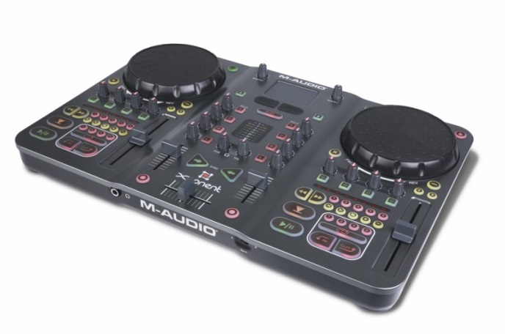](http://cdn.digitaldjtips.com/app/uploads/2011/02/09152620/torq_Xponent.jpg)Avid’s Torq Xponent now comes with Torq 2.0 four-deck software giving this established controller full four-deck capability for the first time.

#### Avid/M-Audio Torq Xponent

Price: [US$399](http://www.amazon.com/gp/product/B000N7ZAIC?ie=UTF8&tag=pbmo-20&linkCode=as2&camp=1789&creative=390957&creativeASIN=B000N7ZAIC) / [£372](http://www.juno.co.uk/products/m-audio-torq-xponent-advanced-dj-performance-production-system-version-1-5/341545-01/?currency=GBP&ref=ddjt) / [€437](http://www.juno.co.uk/products/m-audio-torq-xponent-advanced-dj-performance-production-system-version-1-5/341545-01/?currency=EUR&ref=ddjt)  
Rating: [rating=4]

Supplied software: Torq 2.0 (free upgrade from 1.5); Decks usable with supplied software: 4; Sound card: yes; Phono/line inputs: no; Physical channels: 2; Booth/record out: yes; Mic in: no; Power: USB; Size & weight: 18 x 12 x 2.6″ (458 x 306 x 65mm), 8.2lb (3.7kg)

They say: The professional-grade Torq Xponent system seamlessly integrates high-performance DJ software with a fully functional hands-on controller.

We say: Quality full control system from Avid (previously M-Audio). High-end features include on-the-fly tempo-synced sampling, lots of FX and new in 2.0, 4-deck control. In some ways it’s forerunner to the Traktor Kontrol S4. No extra inputs or outputs though.

See it at: [Amazon.com](http://www.amazon.com/gp/product/B000N7ZAIC?ie=UTF8&tag=pbmo-20&linkCode=as2&camp=1789&creative=390957&creativeASIN=B000N7ZAIC), [Juno.co.uk (UK, rest of Europe & world)](http://www.juno.co.uk/products/m-audio-torq-xponent-advanced-dj-performance-production-system-version-1-5/341545-01/?ref=ddjt)

[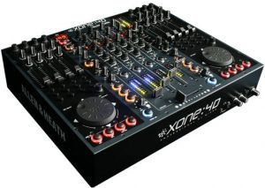](http://cdn.digitaldjtips.com/app/uploads/2011/02/09152615/allen-heath-xone-4d.jpg)Nobody will accuse you of playing with toys if you turn up at a gig with one of these.

#### Allen & Heath Xone:4D

Price: [US$2,200](http://www.amazon.com/gp/product/B001V6V34O?ie=UTF8&tag=pbmo-20&linkCode=as2&camp=1789&creative=390957&creativeASIN=B001V6V34O) / [£1,448](http://www.juno.co.uk/products/allen-heath-xone-4d-professional-digital-dj-mixer-controller-20-channel-usb-audio-interface-graphite-grey/350246-01/?currency=GBP&ref=ddjt) / [€1,992](http://www.juno.co.uk/products/allen-heath-xone-4d-professional-digital-dj-mixer-controller-20-channel-usb-audio-interface-graphite-grey/350246-01/?currency=EUR&ref=ddjt)  
Rating: [rating=4]

Supplied DJ software: Traktor LE, Ableton Live demo; Decks usable with supplied software: 2; Sound card: yes; Phono/line inputs: 4; Physical channels: 4; Booth/record out: yes; Mic in: yes; Power: external; Size & weight: 17 x 14 x 3.5″ (431 x 356 x 89mm), 11lb (5kg)

They say: The Xone:4D continues the seamless integration of computer-based digital media into the traditional DJ workspace, but with a further enhanced feature set.

We say: Highly professional unit aimed at the very high end with a 10-in/10-out sound card and brilliant filters. Not the best for portable digital DJs because of its size and weight, can’t scratch well on it, plus you’ll need a pro software package to use all 4 decks.

See it at: [Amazon.com](http://www.amazon.com/gp/product/B001V6V34O?ie=UTF8&tag=pbmo-20&linkCode=as2&camp=1789&creative=390957&creativeASIN=B001V6V34O) / [Juno.co.uk (UK, rest of Europe & world)](http://www.juno.co.uk/products/allen-heath-xone-4d-professional-digital-dj-mixer-controller-20-channel-usb-audio-interface-graphite-grey/350246-01/?ref=ddjt)

[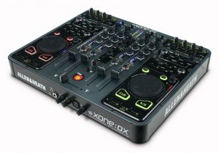](http://cdn.digitaldjtips.com/app/uploads/2010/11/09153016/allen-heath-xone-dx.jpg)Fully featured, fantastic looking, light, strong, compact and a scream to use – It\’s fair to say we like the Xone:DX.

#### Allen & Heath Xone:DX

Price: [US$999](http://www.amazon.com/gp/product/B003JLMWPI?ie=UTF8&tag=pbmo-20&linkCode=as2&camp=1789&creative=390957&creativeASIN=B003JLMWPI) / [£998](http://www.juno.co.uk/products/allen-heath-xone-dx-midi-controller-usb-soundcard/369733-01/?currency=GBP&ref=ddjt) / [€1170](http://www.juno.co.uk/products/allen-heath-xone-dx-midi-controller-usb-soundcard/369733-01/?currency=EUR&ref=ddjt)  
Rating: [rating=5]

Supplied DJ software: Serato ITCH. Sound card: yes; Phono/line inputs: 4; Physical channels: 4; Booth/record out: yes; Mic in: yes; Power: external; Size & weight: 15 x 14 x 2″ (381 x 356 x 51mm), 12lb (5.5kg)

They say: Professional Midi USB controllers integrated with 4-deck Serato ITCH software. The most powerful ITCH controller on the planet.

We say: Thinner, lighter and more portable than the Xone:4D and coming tightly integrated with the elegant Serato ITCH pro software, this is a truly complete controller, let down only slightly by old-style jogwheels. [Read more](http://www.digitaldjtips.com/2011/01/allen-heath-xone-dx-review/)

See it at: [Amazon.com](http://www.amazon.com/gp/product/B003JLMWPI?ie=UTF8&tag=pbmo-20&linkCode=as2&camp=1789&creative=390957&creativeASIN=B003JLMWPI), [Juno.co.uk (UK, rest of Europe & world)](http://www.juno.co.uk/products/allen-heath-xone-dx-midi-controller-usb-soundcard/369733-01/?ref=ddjt)

[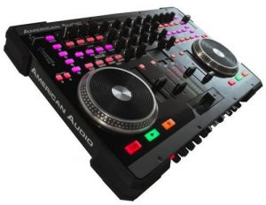](http://cdn.digitaldjtips.com/app/uploads/2011/02/09152620/american-audio-vms4.jpg)It’s one of the most flexible and fully featured DJ controllers in our round up, but it’s not the best built.

#### American Audio VMS4

Price: [US$455](http://www.amazon.com/gp/product/B003RAB97I?ie=UTF8&tag=pbmo-20&linkCode=as2&camp=1789&creative=390957&creativeASIN=B003RAB97I) / [£327](http://www.thomann.de/index.html?partner_id=39004&page=gb/american_audio_vms4.htm) / [€377](http://www.thomann.de/index.html?partner_id=39004&page=gb/american_audio_vms4.htm)  
Rating: [rating=3]

Supplied DJ software: Virtual DJ LE; Decks usable with supplied software: 4; Sound card: yes; Phono/line inputs: 4; Physical channels: 4; Booth/record out: yes; Mic in: yes; Power: USB/external; Size & weight: 19.1 x 12.6 x 2.7″ (487 x 320 x 70mm), 13lb (6kg)

They say: The VMS4 is a 4-Channel “MIDILOG™” controller that fuses both Midi (Midi software) and analog audio control (CD players, turntables etc.) into one unit.

We say: You get a LOT for your money here, like 2 EQed mics, XLR outs, flexible ins, booth control, and great flexibility. Fair quality build reflected in the price.

See it at: [Amazon.com](http://www.amazon.com/gp/product/B003RAB97I?ie=UTF8&tag=pbmo-20&linkCode=as2&camp=1789&creative=390957&creativeASIN=B003RAB97I), [Thomann (UK & rest of Europe)](http://www.thomann.de/index.html?partner_id=39004&page=gb/american_audio_vms4.htm)

[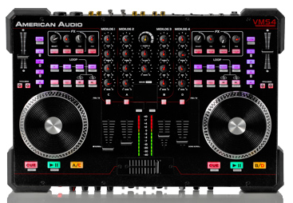](http://cdn.digitaldjtips.com/app/uploads/2011/02/09152619/american-audio-vms4T-review.png)The American Audio VMS4T is pretty much identical to the VMS4, only closely tied to Traktor software and offering four-deck functionality out of the box.

#### American Audio VMS4T

Price: [*US$599*](http://www.musictrends.com/vms4-traktor-p-13968.html)  
Rating: [rating=3]

Supplied DJ software: ; Decks usable with supplied software: 4; Sound card: yes; Phono/line inputs: 4; Physical channels: 4; Booth/record out: yes; Mic in: yes; Power: USB/external; Size & weight: 19.1 x 12.6 x 2.7″ (487 x 320 x 70mm), 13lb (6kg)

They say: We’ve taken the VMS4 and kept all of the features that have made it such a hit over the past year, like the mouse pad and the all-metal jogwheels, and paired it with Traktor software

We say: If you like the original VMS4 but want to use it with Traktor, this is obviously for you. Limited availability means you’ll pay more for it than the Virtual DJ version, though.

See it at: [Music Trends](http://www.musictrends.com/vms4-traktor-p-13968.html)

[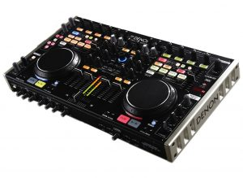](http://cdn.digitaldjtips.com/app/uploads/2011/01/09152707/denon-dn-mc6000-review.jpg)Taking its style cues from previous Denon DJ equipment, the DN-MC6000 is high-tech but workmanlike, and packs a lot of features into its compact case.

#### Denon DN-MC6000

Price: [*US$799*](http://www.amazon.com/gp/product/B004H7YU12?ie=UTF8&tag=pbmo-20&linkCode=as2&camp=1789&creative=390957&creativeASIN=B004H7YU12) / [*£679*](http://www.juno.co.uk/products/denon-dn-mc6000-dj-controller/402351-01/?currency=GBP&ref=ddjt) / [*€795*](http://www.juno.co.uk/products/denon-dn-mc6000-dj-controller/402351-01/?currency=EUR&ref=ddjt)  
Rating: [rating=5]

Supplied DJ software: Virtual DJ 7 LE, Traktor LE; Decks usable with supplied software: 4 (Virtual DJ) / 2 (Traktor); Sound card: yes; Phono/line inputs: 4; Physical channels: 4; Booth/record out: yes; Mic in: yes; Power: External; Size & weight: 18.1 x 10 x 2? (460 x 254 x 51mm), 10.3lbs (4.7kg)

They say: With an astounding amount of features, real-time channel matrix operation, slim tabletop design, state-of-the-art solid steel chassis construction and quality sound, the DN-MC6000 is one of Denon DJ’s flagship controllers.

We say: For serious multi-format DJs, pro mobile DJs, and even for smaller DJ booths, the Denon DN-MC6000 would be ideal. It’s the most flexible 4-channel DJ controller we’ve tested at Digital DJ Tips so far, and overall is a quality piece of kit. [Read more](http://www.digitaldjtips.com/2011/01/review-denon-dn-mc6000-dj-midi-controller/)

See it at: [Amazon.com](http://www.amazon.com/gp/product/B004H7YU12?ie=UTF8&tag=pbmo-20&linkCode=as2&camp=1789&creative=390957&creativeASIN=B004H7YU12), [Juno.co.uk (UK, rest of Europe & world)](http://www.juno.co.uk/products/denon-dn-mc6000-dj-controller/402351-01/?ref=ddjt)

[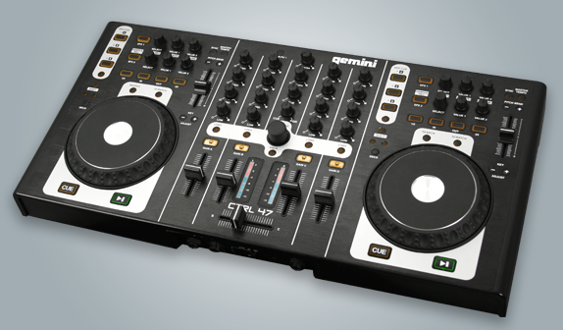](http://cdn.digitaldjtips.com/app/uploads/2011/02/09152619/gemini-ctrl-47.png)The Gemini CTRL-47 looks to be well-built and functional, but we’ve yet to use one ourselves.

#### Gemini CTRL-47

Price: [TBC](http://www.djdeals.com/geminiCTRL47.htm)  
Rating: [rating=3]

Supplied DJ software: Virtual DJ 7 LE; Decks usable with supplied software: 4; Sound card: yes; Phono/line inputs: 1; Physical channels: 4; Booth/record out: yes; Mic in: yes; Power: external; Size & weight: not known

They say: Gemini wrote the book on DJing back in 1974, but now we’re rewriting it. “Digital DJ” was once a bad-word amongst DJs, embodying the loss of control and feel over their DJing trade. But the Gemini CTRL-47 was designed for DJs by the company who knows them better than anyone.

We say: We’re awaiting a review sample of this controller from a veteran DJ brand so our score may change. It looks cleanly laid out, functional and well-built; we’ll let you know if it’s worth the cash once we’ve used one and got a street price.

See it at: Not listed in stores yet

[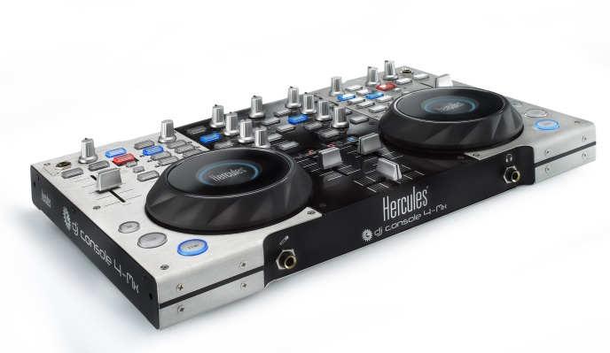](http://cdn.digitaldjtips.com/app/uploads/2010/11/09153014/hercules-dj-console-4-mx.jpg)The DJ Console 4-Mx is stylistically an improvement on the DJ Console RMX, its predecessor, while still retaining the Hercules look and feel to the knobs and buttons.

#### Hercules DJ Console 4-Mx

Price: [US$475](http://www.amazon.com/gp/product/B0047FS5MY?ie=UTF8&tag=pbmo-20&linkCode=as2&camp=1789&creative=390957&creativeASIN=B0047FS5MY) / [£410](http://www.amazon.co.uk/gp/product/B0045X9CMA?ie=UTF8&tag=didjti-21&linkCode=as2&camp=1634&creative=19450&creativeASIN=B0045X9CMA)  
Rating: [rating=4]

Supplied DJ software: Virtual DJ LE; Decks usable with supplied software: ; Sound card: yes: Phono/line inputs: 2; Physical channels: 2; Booth/record out: no; Mic-in: yes; Power: USB; Size & weight: 15 x 9.8 x 2.6″ (381 x 249 x 63mm), 10lb (4.5kg)

They say: Large metal DJ controller with built-in audio and large jog wheels. Professional mix station for mobile and club DJs with included carry bag.

We say: The next generation of their dependable DJ Console RMX controller. Sensitive jog wheels are excellent, and 4 decks future-proofs it. Still somewhat clunky though. [Read more](http://www.digitaldjtips.com/2011/02/review-hercules-dj-console-4-mx/)

See it at: [Amazon.com](http://www.amazon.com/gp/product/B0047FS5MY?ie=UTF8&tag=pbmo-20&linkCode=as2&camp=1789&creative=390957&creativeASIN=B0047FS5MY), [Amazon.co.uk](http://www.amazon.co.uk/gp/product/B0045X9CMA?ie=UTF8&tag=didjti-21&linkCode=as2&camp=1634&creative=19450&creativeASIN=B0045X9CMA)

[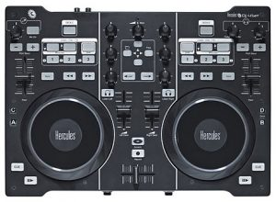](http://cdn.digitaldjtips.com/app/uploads/2011/02/09152618/dj4set-hercules.jpg)The Hercules DJ 4Set won’t be built to pro standards – but the jogwheels are very good, and at this price point that makes all the difference.

#### Hercules DJ 4Set

Price: [US$249](http://www.zzounds.com/item--HERDJ4SET) / [£229](http://www.juno.co.uk/products/hercules-dj-4set-dj-controller-with-built-in-audio-interface/417288-01/?currency=GBP&ref=ddjt) / [€268](http://www.juno.co.uk/products/hercules-dj-4set-dj-controller-with-built-in-audio-interface/417288-01/?currency=EUR&ref=ddjt)

Rating: [rating=4]

Supplied DJ software: Virtual DJ 7 LE; Decks usable with supplied software: 4; Sound card: yes; Phono/line inputs: 0; Physical channels: 2; Booth/record out: no; Mic in: yes; Power: USB; Size & weight: 13.7 x 9.8 x 2″ (350 x 250 x 50mm), 4.4lb (2kg)

They say: Large DJ controller with built-in audio output. The Hercules DJ 4Set combines the functions and feel of a pro controller with the simplicity users need to host memorable parties all night long. All-nighters only.

We say: Looks like this is aimed squarely at the Mixtrack Pro, but with the benefit of being able to control 4 decks. Jogwheels are the same as the 4-Mx, which means they’re very good.

See it at: [ZZsounds (US)](http://www.zzounds.com/item--HERDJ4SET), [Juno.co.uk (UK, rest of Europe & world)](http://www.juno.co.uk/products/hercules-dj-4set-dj-controller-with-built-in-audio-interface/417288-01/?ref=ddjt)

[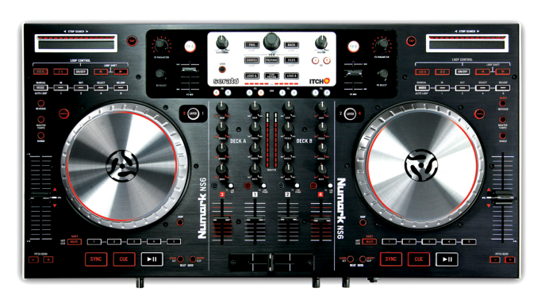](http://cdn.digitaldjtips.com/app/uploads/2011/02/09152618/numark-ns6.png)The Numark NS6 is built to the same standards as the NS7, V7 and X5, but doesn’t look as clean-cut, due to the features crammed into it.

#### Numark NS6

Price: [US$949](http://www.amazon.com/gp/product/B004S1PZP2/ref=as_li_ss_tl?ie=UTF8&tag=pbmo-20&linkCode=as2&camp=217145&creative=399373&creativeASIN=B004S1PZP2) / [£799](http://www.juno.co.uk/products/numark-ns6-dj-controller/416419-01/Juno:%20?currency=GBP&ref=ddjt) / [€905](http://www.juno.co.uk/products/numark-ns6-dj-controller/416419-01/Juno:%20?currency=EUR&ref=ddjt)  
Rating: [rating=5]

Supplied DJ software: Serato ITCH; Decks usable with supplied software: 4; Sound card: yes; Phono/line inputs: 4 line, 2 phono; Physical channels: 4; Booth/record out: yes; Mic in: yes; Power: external; Size & weight: 24 x 13.5 x 2.5″ (600 x 340 x 65mm), 14lbs (6.3kg)

They say: NS6 is the first truly pro-grade DJ controller and standalone four-channel mixer with effects. Simply put, there has never been this much versatility and control available for professional DJs.

We say: With the build quality of the excellent NS7, and jogwheels as good as claimed (even though they look a bit plasticky at the edges), this is a worth high-end contender to the Allen & Heath Xone:DX, which is the only other Serato ITCH four-deck controller there is. [Read more](http://www.digitaldjtips.com/2011/07/numark-ns6-review-dj-controller/)

See it at: [Amazon.com](http://www.amazon.com/gp/product/B004S1PZP2/ref=as_li_ss_tl?ie=UTF8&tag=pbmo-20&linkCode=as2&camp=217145&creative=399373&creativeASIN=B004S1PZP2), [Juno (UK)](http://www.juno.co.uk/products/numark-ns6-dj-controller/416419-01/?currency=GBP&ref=ddjt) / [Juno (rest of Europe & world)](http://www.juno.co.uk/products/numark-ns6-dj-controller/416419-01/?currency=EUR&ref=ddjt)

[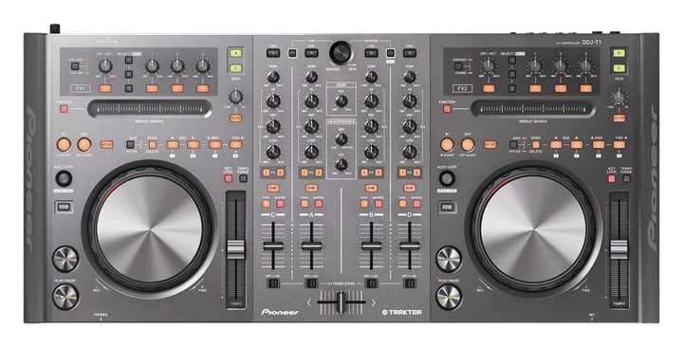](http://cdn.digitaldjtips.com/app/uploads/2011/01/09152806/pioneer-ddj-t1-dj-controller-review.jpg)The Pioneer DDJ-T1 DJ controller is a heavyweight addition to this suddenly crowded end of the market.

#### Pioneer DDJ-T1

Price: [US$999](http://www.amazon.com/gp/product/B004JPYORC?ie=UTF8&tag=pbmo-20&linkCode=as2&camp=1789&creative=390957&creativeASIN=B004JPYORC) / [£899](http://www.juno.co.uk/products/pioneer-ddj-t1-traktor-all-in-one-4-channel-dj-controller-with-integrated-dj-functions-traktor-dj-software/415665-01/?currency=GBP&ref=ddjt) / [€1,053](http://www.juno.co.uk/products/pioneer-ddj-t1-traktor-all-in-one-4-channel-dj-controller-with-integrated-dj-functions-traktor-dj-software/415665-01/?currency=EUR&ref=ddjt)  
Rating: [rating=3]

Supplied DJ software: Traktor Pro; Decks usable with supplied software: 4; Sound card: yes; Phono/line inputs: 1 (emergency thru); Physical channels: 4; Booth/record out: no; Mic in: yes; Power: external; Size & weight: 26.8 x 12.5 x 3.7″ (680 x 317 x 94mm), 10.8lb (4.9kg)

They say: Designed for use with the Traktor software, which makes it possible for DJs to play with music files on a computer. The controller has the same operability and layout as our professional DJ equipment, so you can give high-level performances using Traktor DJ software.

We say: The fact that it’s from Pioneer will open doors for this unit. It’s very wide, well laid out and has a few innovations like the strip search function, but is not particularly well featured otherwise, with few external inputs and no booth out, for instance. For Pioneer fans it will feel great, but the jury’s out on this for value.

See it at: [Amazon.com](http://www.amazon.com/gp/product/B004JPYORC?ie=UTF8&tag=pbmo-20&linkCode=as2&camp=1789&creative=390957&creativeASIN=B004JPYORC), [Juno.co.uk (UK, rest of Europe & world)](http://www.juno.co.uk/products/pioneer-ddj-t1-traktor-all-in-one-4-channel-dj-controller-with-integrated-dj-functions-traktor-dj-software/415665-01/?ref=ddjt)

[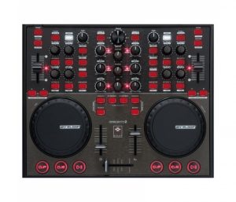](http://cdn.digitaldjtips.com/app/uploads/2011/02/09152617/digital-jockey-2-controller-edition-reloop.jpg)The Reloop Digital Jockey 2 Controller Edition is a good-looking and well laid-out DJ controller.

#### Reloop Digital Jockey 2 Controller Edition

Price: [US$352](http://www.juno.co.uk/products/363990-01.htm?currency=USD&ref=ddjt) / [£218](http://www.juno.co.uk/products/363990-01.htm?currency=GBP&ref=ddjt) / [€256](http://www.juno.co.uk/products/363990-01.htm?currency=EUR&ref=ddjt)  
Rating: [rating=3]

Supplied software: Traktor LE; Decks usable with supplied software: 2; Sound card: no; Physical channels: 2; Power: USB/external; Size & weight: 13 x 11.6 x 1.5″ (370 x 38 x 295mm), 5.5lb (2.5kg)

They say: With the Digital Jockey 2 Reloop gives Traktor DJs a controller that will make sound become truly tangible: A perfect team up.

We say: Sturdy build, a few complaints about the cue buttons failing though. Nice size, but no sound card. Well featured and professional looking, but not the best value at this price unless you already have a sound card, as you’ll need extra software too. [Read more](http://www.digitaldjtips.com/2010/10/reloop-digital-jockey-2-dj-controller-review/)

See it at: [Juno.co.uk (UK, rest of Europe & world)](http://www.juno.co.uk/products/363990-01.htm?ref=ddjt)

[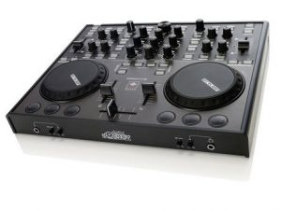](http://cdn.digitaldjtips.com/app/uploads/2011/02/09152616/reloop-digital-jockey-2-interface-edition.jpg)The interface edition is practically identical to the controller edition except of course for the sound card elements like mike and headphones inputs and RCAs round the back.

#### Reloop Digital Jockey 2 Interface Edition

Price: [US$396](http://www.amazon.com/gp/product/B00418F3NG?ie=UTF8&tag=pbmo-20&linkCode=as2&camp=1789&creative=390957&creativeASIN=B00418F3NG) / [£298](http://www.juno.co.uk/products/reloop-digital-jockey-2-interface-edition-version-2/363991-01/?currency=GBP&ref=ddjt) / [€350](http://www.juno.co.uk/products/reloop-digital-jockey-2-interface-edition-version-2/363991-01/?currency=EUR&ref=ddjt)  
Rating: [rating=3]

Supplied software: Traktor LE; Decks usable with supplied software: 2; Sound card: yes; Phono/line inputs: 1; Physical channels: 2; Booth/record out: no; Mic in: yes; Power: USB/external; Size and weight: 13 x 11.6 x 1.5″ (370 x 38 x 295 mm), 6lb (2.7kg)

They say: With the Digital Jockey 2, Reloop gives Traktor DJs a controller that will make sound become truly tangible: A perfect team up.

We say: Adds a soundcard, touch-sensitive jog wheels and input for one external source to the features of the interface edition. An extra line in would have been good – why just one?

See it at: [Amazon.com](http://www.amazon.com/gp/product/B00418F3NG?ie=UTF8&tag=pbmo-20&linkCode=as2&camp=1789&creative=390957&creativeASIN=B00418F3NG), [Juno.co.uk (UK, rest of Europe & world)](http://www.juno.co.uk/products/reloop-digital-jockey-2-interface-edition-version-2/363991-01/?ref=ddjt)

[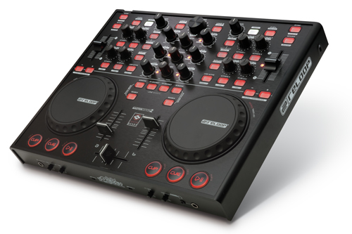](http://cdn.digitaldjtips.com/app/uploads/2011/02/09152616/Reloop-Digital-Jockey-2-Master-Edition.jpg)The Reloop Digital Jockey 2 Master Edition packs a lot of technology into the same case as the rest of the Reloop controller series.

#### Reloop Digital Jockey 2 Master Edition

Price: [US$632](http://www.juno.co.uk/products/reloop-digital-jockey-2-master-edition/389796-01/?currency=USD&ref=ddjt) / [£389](http://www.juno.co.uk/products/reloop-digital-jockey-2-master-edition/389796-01/?currency=USD&ref=ddjt) / [€445](http://www.juno.co.uk/products/reloop-digital-jockey-2-master-edition/389796-01/?currency=USD&ref=ddjt)  
Rating: [rating=4]

Supplied software: Traktor LE; Decks usable with supplied software: 2; Sound card: yes; Phono/line inputs: 2; Physical channels: 2; Booth/record out: yes; Mic in: yes; power: external; Size & weight: 13 x 11.6 x 1.5″ (370 x 38 x 295 mm), 6lb (2.7kg)

They say: All the critically acclaimed controller features are still on board, but now it comes with symmetric output, booth output and standalone mixing.

We say: Sophisticated channel routing, club, booth and master outputs, works as an analogue mixer without laptop plugged in, and nice and compact meaning easier to carry around than many of these. A good contender.

See it at: [Juno.co.uk (UK, rest of Europe & world)](http://www.juno.co.uk/products/reloop-digital-jockey-2-master-edition/389796-01/)

[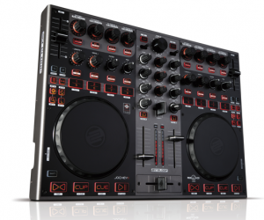](http://cdn.digitaldjtips.com/app/uploads/2011/02/09152617/reloop-jockey-3-master-edition.png)The Reloop Jockey 3 Master Edition is completely metal cased and has excellent jogwheels. It is shaping up to be a desirable new controller.

#### Reloop Jockey 3 Master Edition

Price: [US$802](http://www.juno.co.uk/products/reloop-digital-jockey-3-me-mission-iii/417296-01/?currency=GBP&ref=ddjt) / [£499](http://www.juno.co.uk/products/reloop-digital-jockey-3-me-mission-iii/417296-01/?currency=GBP&ref=ddjt) / [£584](http://www.juno.co.uk/products/reloop-digital-jockey-3-me-mission-iii/417296-01/?currency=GBP&ref=ddjt)  
Rating: [rating=4]

Supplied DJ software: Traktor 2 LE; Decks usable with supplied software: 4 (expected); Sound card: yes; Phono/line inputs: 2; Physical channels: 2; Booth/record out: yes; Mic in: yes; Power: external; Size & weight: 16.5 x 11.8 x 1.6″ (420 x 300 x 42mm), 9.9lb (4.5kg),

They say: Since the introduction of the highly successful Digital Jockey series, Reloop stands for digital tradition and consistent further development on the DJ controller market. With MISSION III, namely the Jockey 3, the Digital Jockey series will be newly defined.

We say: Well laid out, excellent build quality, great jog wheels, lots of inputs and outputs, and tight integration with 4-deck Traktor. Right blend of size, weight, quality and feature make this a desirable controller, but we’ve not tested it yet.

See it at: [Juno.co.uk (UK, rest of Europe & world)](http://www.juno.co.uk/products/reloop-digital-jockey-3-me-mission-iii/417296-01/?currency=GBP&ref=ddjt)

[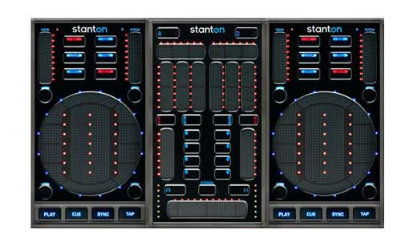](http://cdn.digitaldjtips.com/app/uploads/2011/02/09152616/StantonSCS3DJController.jpg)One of the best looking little controllers out there, with three parts that clip together magnetically.

#### Stanton SCS3 DJ Control System

Price: [US$499](http://www.amazon.com/gp/product/B002TP500E?ie=UTF8&tag=pbmo-20&linkCode=as2&camp=1789&creative=390957&creativeASIN=B002TP500E) / [£379](http://www.dolphinmusic.co.uk/product/47327-stanton-sc-system-3-controller-package.html?locale=en_GB) / [€433](http://www.dolphinmusic.co.uk/product/47327-stanton-sc-system-3-controller-package.html?locale=de_DE)  
Rating: [rating=5]

Supplied software: Traktor LE; Decks usable with supplied software: ; Sound card: no; Physical channels: 2; Power: USB; Size & weight: 14.2 x 8.5 x 1.4in (360 x 216 x 35mm), 3.5lb (1.6kg)

They say: The most innovative, completely mobile Midi control solution available, with 2 touch-sensitive control surfaces for customizable software control.

We say: Compact, innovative, clever and capable, this is a bold and well thought-out innovation from Stanton. True portable 4-channel DJing – it even splits up into three parts for stashing. You’ll need a sound card though.

See it at: [Amazon.com](http://www.amazon.com/gp/product/B002TP500E?ie=UTF8&tag=pbmo-20&linkCode=as2&camp=1789&creative=390957&creativeASIN=B002TP500E), [Dolphin Music (UK)](http://www.dolphinmusic.co.uk/product/47327-stanton-sc-system-3-controller-package.html?locale=en_GB), [Dolphin Music (rest of Europe)](http://www.dolphinmusic.co.uk/product/47327-stanton-sc-system-3-controller-package.html?locale=de_DE)

[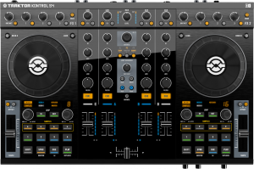](http://cdn.digitaldjtips.com/app/uploads/2010/11/09153004/traktor-kontrol-s4.png)Traktor is the most popular DJ software, so a controller designed by its makers specially for it is bound to be big news.

#### Traktor Kontrol S4

Price: [US$899](http://www.amazon.com/gp/product/B004A95HDW?ie=UTF8&tag=pbmo-20&linkCode=as2&camp=1789&creative=390957&creativeASIN=B004A95HDW) / [£749](http://www.amazon.co.uk/gp/product/B004A95HDW?ie=UTF8&tag=didjti-21&linkCode=as2&camp=1634&creative=19450&creativeASIN=B004A95HDW) / [€877](http://www.dolphinmusic.co.uk/product/46357-native-instruments-traktor-kontrol-s4.html?locale=de_DE)

Rating: [rating=5]

Supplied DJ software: Traktor Pro 2 (after April 1 2011), Traktor S4 Edition (free upgrade); Decks usable with supplied software: 4; Sound card: yes; Phono/line inputs: 2; Physical channels: 4; Booth/record out: no; Mic in: yes; Power: USB/external; Size & weight: 19.7 x 12.7 x 2″ (50 x 32.3 x 5.1cm), 10.3lb (4.7kg)

They say: Forget what you know about DJ controllers and DJ software. Traktor Kontrol S4 was designed from its conception as a fully integrated system where software and hardware are fused in perfect harmony.

We say: High quality unit, pretty large but light, good solid jogs, lots of features, and of course tight integration with Traktor. For this price we’d like to see XLR outs and separate booth monitor, but their lack is made up for by sample decks and other new features. Most popular DJ controller among our readers.

See it at: [Amazon.com](http://www.amazon.com/gp/product/B004A95HDW?ie=UTF8&tag=pbmo-20&linkCode=as2&camp=1789&creative=390957&creativeASIN=B004A95HDW), [Amazon.co.uk](http://www.amazon.co.uk/gp/product/B004A95HDW?ie=UTF8&tag=didjti-21&linkCode=as2&camp=1634&creative=19450&creativeASIN=B004A95HDW), [Dolphin Music (Europe)](http://www.dolphinmusic.co.uk/product/46357-native-instruments-traktor-kontrol-s4.html?locale=de_DE)

[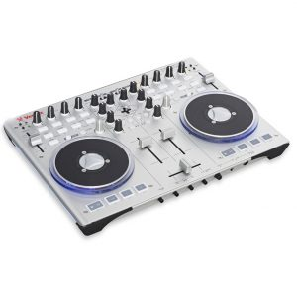](http://cdn.digitaldjtips.com/app/uploads/2011/02/09152615/vestax-cvi-100-mk-ii.jpg)More logically laid out but with blue underlighting that may not be to everyone’s taste: The Vestax VCI-100 MkII.

#### Vestax VCI-100 MkII

Price: [US$630](http://www.amazon.com/gp/product/B0046OY64C?ie=UTF8&tag=pbmo-20&linkCode=as2&camp=1789&creative=390957&creativeASIN=B0046OY64C) / [£399](http://www.juno.co.uk/products/vestax-vci-100-mkii-usb-midi-dj-controller/407589-01/?currency=GBP&ref=ddjt) / [€467](http://www.juno.co.uk/products/vestax-vci-100-mkii-usb-midi-dj-controller/407589-01/?currency=EUR&ref=ddjt)  
Rating: [rating=4]

Supplied software: Traktor LE; Decks usable with supplied software: 2; Sound card: yes; Phono/line in: no; Physical channels: 2; Booth/record out: yes; Mic in: no; Power: USB/external; Size & weight: 14.1 x 10.6 x 1.5″ (368 x 270 x 38mm), 4.4lb (2kg)

They say: Over the years as the entire DJ scene made its shift to computer based DJing, we kept collecting requests and demands for a new model. Here it is: VCI-100 MkII.

We say: It’s lighter, still well made, the jog wheels have torque controls, it’s better laid out than the originals, it looks the part and it’s a great compact size. Misses mic and external inputs at this price point, though.

See it at: [Amazon.com](http://www.amazon.com/gp/product/B0046OY64C?ie=UTF8&tag=pbmo-20&linkCode=as2&camp=1789&creative=390957&creativeASIN=B0046OY64C), [Juno.co.uk (UK, rest of Europe, world)](http://www.juno.co.uk/products/vestax-vci-100-mkii-usb-midi-dj-controller/407589-01/?currency=GBP&ref=ddjt)

### Conclusion

The DJ controller market is moving fast, and manufacturers are racing hand over foot to try and differentiate their products. We’re in a period of change: I can’t see it being acceptable to offer a four-deck controller with two-deck software for much longer, for instance.

With the extra price of 4-deck models comes the expectation of extra features – at the very least a microphone input and following that, the ability to plug some kind of external source or sources through the unit, even if it is just that – an emergency “thru” so you can have your iPod ready to take over if you suffer a crash while DJing.

Some of the new units, particularly the Numark NS6 and Reloop Jockey 3, look really promising, but there’s absolutely no point waiting for the next big thing if you’re in the market for a controller today.

There are models here on open sale now that can keep you happily being creative for years, so take your pick from what’s available in your territory and get out there DJing.

Good luck – and let us know how you get on.